Emergency Evacuation
Operations Plan

Mechanical Engineering
Building

2015

Introduction
Environmental Health and Safety (EH&S) developed this model Emergency Evacuation and Operations Plan (EEOP) to assist departments in preparing for building emergencies as expected and required by University policy, the Seattle Fire Code, and the Washington Administrative Code (WAC). This plan is intended for use by multiple departments and may be completed as a departmental or building evacuation plan. For buildings which are taller than four stories (High Rise Buildings), refer to additional requirements in Appendix P.
It is expected that departments will customize and complete this plan to meet their specific needs, operations, and locations. Departments and/or colleges with multiple buildings may develop a single plan for their facilities, as long as building specific information for each facility is included in Appendices A through D.
Review and dialog among multiple departments within a single building and/or individual fire zones must be part of the process of completing a building specific EEOP. Staff from EH&S are available to provide technical assistance, including reviewing a final draft of your EEOP.
The model EEOP was written to complement and supplement the University of Washington All-Hazards Emergency Management Plan (EMP) for campus operations during large scale or campus-wide emergencies. A copy of the UW EMP should be maintained in your department. Copies of the campus plan are available from the Office of Emergency Management and online at their website. Reviewing the campus EMP may be helpful while completing the attached EEOP. See Appendix J for more details.
Considerable effort has gone into trying to make this plan concise, clear, easy to use, and easy to implement. If we can be of further assistance, please contact us at (206) 543-0465.

Fire Prevention
Environmental Health and Safety

Building and Fire Safety
Environmental Health and Safety
University of Washington
Box 354400
Seattle, WA 98195-4400

Instructions
This EEOP is a model plan that requires certain sections be completed by each department in order to individualize the plan for their building. The following instructions provide a list of items that need to be finished for this plan to be completed. EH&S also recommends that each department include a letter from their Department Chair approving adoption of this plan. In addition, it is important that Evacuation Directors and Evacuation Wardens read through this document in order to become familiar with its contents, requirements, and procedures.
If you have multiple buildings in your department or college, you may develop a single EEOP to cover these multiple facilities. In this case, include building specific information for each of your facilities in Appendices A through D.
- Cover Page: Insert name of Building on cover page.
- Section 1:
- Purpose: Insert Building Name.
- Scope: Complete this section with department/building specific information.
- Coordination with Other Emergency Plans: List plans for other departments in your building.
- Coordination with Departmental Health and Safety Plans: List other departmental health and safety plans.
- Emergency Communications: Identify additional backup phone service. Include other monitored communication systems such as alarm equipment, radios, cell phones, etc.
- Section 2:
- Responsibilities of the Evacuation Director: Italicized text should be read and considered before selection of the Evacuation Director. Delete this text after it has been read.
- Appendix A: Completely fill in.
- Appendix B: Completely fill in or note if Appendix B is not applicable.
- Appendix C: Completely fill in. Prepare floor plans and maps showing evacuation routes, areas of safe refuge for persons with disabilities, locations of Evacuation Assembly Points (look at the evacuation maps posted in your buildings for location of your EAPs), and mass assembly areas (see Appendix O for campus map of mass assembly areas).
- Appendix D: If you have persons with disabilities, work with them to develop emergency evacuation plans. This Appendix includes a blank form to help develop an evacuation plan, as well as detailed guidance for emergency evacuation for persons with disabilities.

Contents
Introduction 1
Instructions 2
Section 1 5
Purpose 5
Scope 5
Coordination with Other Emergency Plans 5
Coordination with Departmental Health and Safety Plans 5
University Emergency Resources and Contacts 5
Emergency Communications 6
Employee Orientation 6
Evacuation Drills 6
Table 1: University Emergency Resources and Contacts 7
Section 2 9
Responsibilities of UW Departments and Staff 9
Responsibilities of the Evacuation Director and Evacuation Wardens 9
Responsibilities of Faculty, Lecturers, and Teaching Assistants 10
Checklist 1: Evacuation Director Duties and Responsibilities 11
Checklist 2a: Evacuation Warden Pre-evacuation Planning and Coordination 14
Checklist 2b: Evacuation Warden Emergency Evacuation Duties 15
Checklist 3: Duties and Responsibilities of Faculty, Lecturers, and TAs 17
Section 3 18
Procedure 1: Fire Emergencies and Building Fire Alarms 18
Procedure 2: Earthquakes 20
Procedure 3: Hazardous Material Spills 22
Procedure 4: Bomb Threats 22
Procedure 5: Suspicious Packages and Mail 24
Procedure 6: Anthrax Threat 25
Procedure 7: Medical Emergencies 26
Procedure 8: Civil Demonstrations 26
Appendix A 27
Evacuation Director and Alternates 27
Evacuation Wardens and Alternates 27
First Aid Contacts 28
UW First Aid Plan Guidelines 29
Appendix B 30
Instructions 30
Hazardous Locations and Laboratory Personnel 30
Appendix C 31
Evacuation Assembly Points 31
Areas of Safe Refuge 31
Evacuation Plans 31
Appendix D 34
Evacuation Options for Persons with Disabilities 35
Disability Guidelines 36
Evacuation Plan for Persons with Disabilities 37
Appendix E 39
Preparation for an Evacuation Drill 39
The Day Before a Drill 39
Appendix F 40
Conducting an Evacuation Drill 40
Appendix G 40
Conducting the Evacuation Drill 40
Appendix H 41
Evacuation Drill Report Form 41
Appendix I 44
Evacuation Warden Headcount Checklist 44
Appendix J 46
The UW All-Hazards Emergency Management Plan 46
Purpose of the Emergency Management Plan 46
Appendix K 47
Supervisory Responsibilities 47
How to Report an Emergency 48
Emergency Information for Faculty, Lecturers and TAs 48
Classroom Emergency Procedures 50
Appendix L 51
Emergency Evacuation and Planning Checklist: Part 1 52
Emergency Evacuation and Planning Checklist: Part 2 54
Appendix M 58
Buildings with Special Considerations 58
Evacuation Director Post-earthquake Checklist 59
Appendix N 62
List of Acronyms 62
Appendix O 63
Current UW Mass Assembly Areas 63
Appendix P 64
High-rise Evacuation Plans 64
Evacuation Planning and Drills 65
Special Instructions for Evacuation Wardens 65
High-rise Procedures for Occupants 65
Appendix Q 66
UW Health and Safety Plan 66

Section 1
Purpose, Scope, and Emergency Resources

Purpose
The purpose of this plan is to establish procedures and duties, to promote planning, and to establish staff training for fire, earthquake, bomb threats, chemical spill, and other emergency evacuations as required by Chapter 4 of the Seattle Fire Code, the Washington Administrative Code (WAC 296-24-567), and the UW All-Hazards Emergency Management Plan.

Scope
This plan applies to all occupants in the Mechanical Engineering Department as follows:
Mechanical Engineering - basement, ground, and floors 1, 2, and 3.
Engineering Annex – floor 1

Coordination with Other Emergency Plans

An EEOP is a key component of Departmental Health and Safety Plans and University disaster planning. The EEOP must be coordinated with the following emergency/safety plans.
- The UW All-Hazards Emergency Management Plan: The EMP provides the management structure, key responsibilities, emergency assignments, and general procedures to follow during and immediately after an emergency. It provides a temporary crisis management structure, which provides for the immediate focus of management on response operations and the early transition to recovery operations. The EMP includes procedures for communicating with the UW Emergency Operations Center as well as the management structure of the Incident Command System. The EMP can be found online here:
http://www.washington.edu/uwem/files/2014/10/2014-FINAL-Public-version-with-NO-phone-numbers.pdf
- Other Departmental Emergency Response Plans: This departmental plan has been coordinated as necessary with other departmental plans in the building as follows:
Industrial & Systems Engineering – Shiela Prussa

Coordination with Departmental Health and Safety Plans
The EEOP reflects the university's emergency response procedures and programs and satisfies an element of the Departmental Health and Safety Plan required by the Department of Labor and Industries (WAC 296-24-567).

The ME Department Health and Safety Plan can be found online here:

http://www.me.washington.edu/files/students/docs/ME-Health-Safety-Plan.pdf
The ME Department Shop Safety Plan can be found online here:

http://www.me.washington.edu/files/students/docs/shop-safety-plan.pdf

University Emergency Resources and Contacts
Table 1 summarizes the UW’s emergency resources, contact information, and responsibilities of each emergency resource.

Emergency Communications
- Telephones: The campus telephone system will be used to the extent possible. In case of system failure or a power failure, campus phones will not function. An alternative in some buildings is the emergency single line phones, which could function in a power outage. These phones, part of the UW’s Emergency Communications System (ECS), are strategically located in nearly 200 locations throughout campus. Mechanical Engineering personnel will serve as messengers if phone communication is not an option.

- Fire Alarm System: The building fire alarm system is continuously monitored for alarm by a contracted service and, in a backup capacity, by the UWPD Communication Center. All alarms result in an automatic response by Seattle Fire Department, UWPD, and Facilities Services’ FOMS unit.
- Personal Cell Phones: Employees are encouraged to offer personal cell phones in emergency situations if service is available.
- Runners: Employees are encouraged, if outfitted properly, to act as runners to the Emergency Operations Center (EOC). See Table 1 for locations.

Employee Orientation
New employees must be informed of the EEOP as part of their new employee safety orientation. This initial plan and all significant revisions to the plan should be routed to all personnel. The faculty and staff should be reminded of the plan as necessary and encouraged to discuss the plan with their research groups, students, and visitors. To assure the safety of all building occupants, the Evacuation Director and Evacuation Wardens will work together to assure all departmental employees are aware of the plan, and that students and visitors are also oriented as indicated in Section 2.

Evacuation Drills
Evacuation drills will be scheduled, conducted, and recorded by the Evacuation Director. Procedures for planning, scheduling, conducting, evaluating, recording, and reporting evacuation drills are outlined in Appendices E, F, and G.

Table 1: University Emergency Resources and Contacts
Emergency Resource | Contact Information | Purpose & Responsibilities
UW Police Department  (UWPD)  Bryant Building  1117 NE Boat Street | Emergency Assistance:  From a UW phone, Dial 9-1-1.  Non-Emergency Assistance:  206-685-8973 | UWPD maintains an Emergency Communications Center 24 hours a day, 7 days a week. Call UWPD for emergencies of any kind, including but not limited to fire, medical emergency, or hazardous material spills or release.
Environmental Health and Safety (EH&S)  201 Hall Health Center | Call 206-543-0462.  After normal business hours, EH&S may be reached through the UWPD using the EH&S Duty Officer system. | EH&S maintains guidelines and provides training, consultation and support for building emergencies. EH&S is also available to provide consultation and support for hazardous material spills and releases, temporary controls, and other general information to the Seattle Fire Department (SFD), UWPD, and UW departments.
Facilities Services  (FOMS & ATC-20) | Routine and emergency services (essential services are covered 24 hours a day) may be obtained by calling: 206-685-1411 or through UWPD. | Facilities Services maintains a 24 hours a day, 7 days a week response unit called “FOMS” or “Unit 2.” The FOMS respond automatically to all fire alarms, and other emergencies to provide support for the UWPD and SFD. This support includes, but is not limited to, the operating/resetting of the fire alarm system; operating the heating, ventilation, and air-conditioning systems (HVAC); and the shutdown of steam, water, electrical, and other utilities. Also provides ATC-20 teams for rapid structural assessments of buildings following earthquakes.
UW Office of Emergency Management  (UWEM) | Call 206-897-8000 during normal business hours. | UWEM staff is available during normal business hours to provide general disaster planning guidance and training resources to faculty and staff. UWEM maintains and coordinates all EOC activities and campus-wide disaster drills and recovery efforts.
Report all emergencies to the UWPD immediately.
Table 1: University Emergency Resources and Contacts cont.
Emergency Resource | Contact Information | Purpose & Responsibilities
UW Emergency Operations Center (EOC) | The primary EOC is located in UW Tower, 4333 Brooklyn Ave NE, Room C-140. The secondary EOC location is Poplar Hall, Rooms 105 & 106 | For a major local or regional emergency, the UW President or his/her designee may request activation of the University’s Emergency Operations Center (EOC). EOC staff will decide on the use of available resources and communicate with outside agencies and authorities. Information on missing persons, building emergencies, first aid, and other needs during a large-scale emergency must be provided to the EOC by using campus telephone systems, computer, (See Emergency Communications in Section 1) or by runner if the telephone systems fail.
KOMO 1000 AM | On the radio at AM 1000 and/or call UW 206-897-4636 | The Official Area Broadcast Station in case of major disaster or University “suspended operations.” Tune into this station for information.
Report all emergencies to the UWPD immediately.

Section 2
Building Evacuation: UW Personnel Duties and Responsibilities
An effective emergency evacuation and subsequent response requires the coordination of many occupants in a building. All building occupants, including employees, faculty, staff, and students, need to be aware of their roles and responsibilities in case of an emergency. This section outlines specific responsibilities for employees, faculty, and staff, as well as the Evacuation Director and Evacuation Wardens.

Responsibilities of UW Departments and Staff
Employees, Faculty, and Staff are responsible for:
- Being familiar with and following EEOP procedures when required
- Participating in drills and training as required
- Orienting students with a brief overview of emergency evacuation procedures on the first day of class to assure that:
- They are aware that evacuation is required when the alarm system is activated.
- They know where the nearest exits are located (see Appendix K, and building plans in Appendix C).
- Informing and assisting visitors unfamiliar with building procedures as appropriate prior to and during an emergency evacuation

Responsibilities of the Evacuation Director and Evacuation Wardens
The Evacuation Director, Evacuation Wardens, and their alternates are employees and occupants of the building and have either volunteered or been appointed to serve in these positions. They receive special training and the authority for their role in employee safety.
Evacuation Director Responsibilities and Control
- The Evacuation Director acts as the liaison with the responding emergency service, EH&S, and others in the event of a building emergency. In their absence, the alternates are responsible for carrying out the requirements. If an emergency happens when these members of the department are not available, the most senior employee will have decision-making authority. A contact person, appointed by the advisor of each research group, is responsible for laboratories and work areas (See Appendices A and B). Any possible problem areas should be reported to responding emergency personnel.
- For a community wide event (Level III), the Evacuation Director or an alternate will establish contact with their Unit Response Center if their department/building has one. Otherwise contact the UW Emergency Operations Center (EOC) directly. The first location for the EOC at the UW Tower 4333 Brooklyn Room C-140. The secondary location is in rooms 105 and 106 at Poplar Hall. Contact will be established by normal phone system (9-1-1), single line phones or runners.
- Refer to Checklist 1 on the following page for a detailed list of the Evacuation Director duties and responsibilities.
Evacuation Warden Duties and Responsibilities
Checklists 2a and 2b list the responsibilities and duties of the Evacuation Wardens. Checklist 2a is for pre-evacuation planning and training. Checklist 2b lists the Evacuation Warden’s duties and procedures during emergency evacuations.

Responsibilities of Faculty, Lecturers, and Teaching Assistants
Checklist 3 lists the responsibilities and duties of faculty, lecturers, and TAs (also see Appendix K).

Checklist 1: Evacuation Director Duties and Responsibilities
Subject Area | Duties / Responsibilities
Administrative | Prepare and maintain the building EEOP. | ☐
 | Keep a copy of the completed EEOP in all department reference stations. | ☐
 | Review the EEOP at least annually and confirm that it is current. | ☐
Pre-Emergency Coordination | Coordinate with building/department administrators responsible for employee, student, and visitor health and safety. | ☐
 | Ensure that public event staff are assigned duties and receive required training for events with occupancy of 50 or greater (see Appendix G). | ☐
 | Ensure that classroom instructors inform students about emergency procedures, exit routes, and assembly points on the first day of class. | ☐
 | Ensure that emergency procedures for special needs populations are developed. | ☐
 | Ensure that new and temporary employees, including student employees, are informed about emergency procedures outlined in the EEOP during new employee safety orientation. | ☐
Evacuation  Wardens | Assign Evacuation Wardens (and alternates) for all areas of the building and ensure that they know what their duties are in case of an evacuation. | ☐
 | Evacuation Warden orientation is required when there are personnel changes. | ☐
 | A current list of Evacuation Wardens and alternates is to be maintained in the building's EEOP (see Appendix A). | ☐
 | Schedule “Evacuation Warden Training” for assigned personnel. Contact the EH&S Training Office. | ☐
Training and  Drills | Schedule, conduct, and record evacuation drills as required by the Seattle Fire Code and WAC 296-24 (see Appendices E, F, and G). | ☐
Emergency Evacuation | Ensure that emergency services, UWPD, FOMS, SFD, and EH&S are notified for all building emergencies as appropriate. | ☐
 | During a building evacuation, report to the evacuation assembly point and act as a liaison with responding emergency services. | ☐
 | Receive status reports from area evacuation wardens. | ☐
 | Provide information about the building layout, systems, processes, and special hazards to Facility Services, SFD, UWPD, and other emergency personnel. | ☐
 | Help the Facility Services Personnel (FOMS), and the SFD in the operation of the Fire Alarm Panel if required. | ☐
 | Coordinate with building administrators on occupancy and operation issues. | ☐
 | Assign Evacuation Wardens or other personnel, as needed, to be stationed by all entrances to prevent unsuspecting personnel from reentering the building. | ☐
 | When SFD or UWPD signals "ALL CLEAR," the Evacuation Director notifies the Evacuation Wardens that the occupants may reenter the building. | ☐

Evacuation Director Checklist
Name: |  |  | Date:
Building: |  |  | Time: |  | am/pm
Location within building (floor, wing, room):
Type of incident (manual pull, smoke, sprinkler):
Evacuated Floors:
Evacuation Assembly Point (EAP):
Secondary EAP:

Evacuation Tasks
- Collect hat, phone, clipboard, and personal belongings.
- Report to the building entrance.
- Tell those evacuating and anyone trying to reenter the building to go to the primary EAP. If the primary EAP is unavailable, send everyone to the secondary evacuation assembly point.
- Collect known information about the incident from individuals evacuating the building (fire, smoke, persons in building, etc.).
- Ask 1st evacuation warden for known information about the incident.
- Report known information to emergency personnel (approximately10 min. after incident).
- Stay at the front of building for further direction from emergency personnel.
Assignment | Name
1st Evacuation Warden – assign to EAP
(They should have a phone, hat, whistle, and clipboard.)
2nd Evacuation Warden – assign to front entrance to help Evacuation Director maintain communication with EAP
3rd Evacuation Warden – assign to door, directing all to EAP
4th Evacuation Warden – assign to door, directing all to EAP
All other Evacuation Wardens assign to EAP
Known Info (fire, smoke, persons in building, etc.) | Provided by

After the All-Clear Signal
- Call 1st Evacuation Warden at the EAP to allow the staff to return and reenter the building.
- Assign an Evacuation Warden to assist staff with disabilities back to their rooms.
- De-brief all Evacuation Wardens (collect facts) to write-up a report and submit to EH&S.

Important Phone Numbers and Contact Information
Building Coordinator: |  | Sue Chen (206) 543-6835
Evacuation Director: |  | Sue Chen (206) 543-6835
Evacuation Director Back-up: |  | Bill Kuykendall (206) 685-7061
1st Floor Warden: | Bill Kuykendall (206) 685-7061
2nd Floor Warden: | Nick Paradis (206) 616-1867
3rd Floor Warden: | Nick Paradis (206) 616-1867
G Floor Warden: | Michelle Hickner (206) 221-8246
B Floor Warden: | Michelle Hickner (206) 221-8246

Staff with Disabilities
Name | Room | Area of Refuge

Notes

Checklist 2a: Evacuation Warden Pre-evacuation Planning and Coordination
Subject | Duties / Responsibilities
Administrative | Be familiar with the EEOP. It contains:  - The function and activities of building staff during emergencies  - How to coordinate with responding emergency personnel  - Information on the building and its emergency protection systems  - Emergency equipment testing procedures  - A list of all the evacuation wardens in your building | ☐
 | Distribute copies of the completed EEOP, or appropriate sections of it, to all people in your area of responsibility. | ☐
Pre-Emergency Coordination | Know where persons with disabilities are located in your area and what their alarm response will be (See Appendix D). Areas of Refuge or individual rooms may be used by persons with mobility disabilities during a fire alarm. The Areas of Refuge may be identified on your evacuation plans found in Appendix C. If you have a staff member with a mobility disability and cannot find an area of refuge on your floor plan, contact EH&S Fire Safety at 206-616-5519 | ☐
 | Coordinate with the other Evacuation Wardens on your floor to work together and avoid duplication of tasks. | ☐
 | Walk over your primary and secondary evacuation routes at least once to familiarize yourself with emergency exits and routes to the Evacuation Assembly Points (EAPs). | ☐
 | Know where hazardous conditions or situations in your area may exist. Know the location of flammable, radioactive and other hazardous materials, as well as chemical and/or biological spill cleanup kits. | ☐
 | Know where the phones and pull stations are and know HOW to turn on an alarm. | ☐
 | Know how the alarm system responds. For most buildings, the alarm sounds throughout the building and all occupants, except persons with physical disabilities, must evacuate. High-rise buildings may only alarm in certain floors or areas. | ☐
 | Become familiar with the location and operation of emergency equipment, including fire extinguishers, first aid kits, spill cleanup kits, and disaster supply kits. | ☐
Training | Attend training sessions and meetings to review procedures and duties, if necessary. EH&S and SFD offer Evacuation Warden training sessions regularly. | ☐
 | Participate in evacuation drills as requested by Evacuation Director. | ☐

Checklist 2b: Evacuation Warden Emergency Evacuation Duties
Subject | Duties / Responsibilities
Building  Evacuation | Begin at the farthest reach of your area and assure that the occupants ahead of you have evacuated. Direct occupants to the exits and tell them where to reassemble. | ☐
 | Conduct a quick search as you go to make sure hazardous equipment is shut off, doors are closed and no one is left behind. | ☐
 | If a stairway is full of smoke go to another stairway. | ☐
 | If there is smoke in the hall, stay low, cover your mouth with a damp cloth or handkerchief, visualize where the exits are, stay close to and use the wall to guide you so you do not become confused. | ☐
 | If there is no smoke, you may have trouble getting people to evacuate. Be assertive, positive and insistent. | ☐
 | Students and visitors who may not be familiar with this plan must be informed of the requirement to evacuate. | ☐
 | If you have helpers, station them in front of the elevator to make sure no one attempts to use it. | ☐
 | Do not go to the roof unless it is the only way out; often, there are too many obstructions for a helicopter rescue. | ☐
At the EAP | Conduct a headcount by using the checklist in Appendix I to account for all occupants in your area of responsibility. | ☐
 | Immediately report to the Evacuation Director any missing persons on your list and their last known location. | ☐
Special Items | Do not allow the stairway doors and other exit doors to be blocked/wedged open. Leaving stairway doors blocked or held open makes the stairwells dangerous and unusable. | ☐
 | Special attention needs to be given to all persons with disabilities, in particular those who are visitors and unfamiliar with the building. A process is necessary to insure they are notified and accounted for. See Appendix D for further details. | ☐
Note: Silencing of the alarm is NOT to be considered an all-clear signal!

Evacuation Warden Checklist
Name: |  |  | Date:
Building: |  |  | Time: |  | am/pm
Location within building (floor, wing, room):
Type of incident (manual pull, smoke, sprinkler):
Evacuated Floors:
Evacuation Assembly Point (EAP):
Secondary EAP:

Evacuation Tasks
- Collect hat, phone, clipboard, and personal belongings.
- Check in with the Evacuation Director at a predetermined location (lobby, etc.).
- Report to the Evacuation Assembly Point (EAP).
- Collect known information about the incident from individuals at the EAP (fire, smoke, persons in building, etc.).
- Report the collected information to the Evacuation Director via mobile phone or runner.
- Keep all staff, visitors, and others away from the building. Do not allow reentry.
- Await further instruction from the Evacuation Director.
Known Info (fire, smoke, persons in building, etc.) | Provided by

After the All-Clear Signal
- Allow occupants to reenter the building.
- Report to the Evacuation Director at the front of the building for de-briefing.
Notes

Checklist 3: Duties and Responsibilities of Faculty, Lecturers, and TAs
Subject Area | Duties / Responsibilities
Administrative/  Preparation | Provide classroom or audience with general information relating to emergency procedures. This information should be shared during the first week of class or at the start of a seminar. Note the posted information for “Classroom Emergency Procedures/Checklist” (See Appendix K). | ☐
 | Know how to report an emergency from the classroom being used. | ☐
 | Assure that persons with disabilities have the information they need. The instructor should be familiar with the student’s plan and also be able to direct visitors with disabilities. | ☐
Emergency  Evacuation | Take responsible charge of the classroom and follow emergency procedures for all building alarms and emergencies. | ☐

Section 3
Specific Emergency Procedures

Procedure 1: Fire Emergencies and Building Fire Alarms

Procedures for Occupants
- When an alarm sounds on your floor or area, begin immediate evacuation following your floor plan (see Appendix C). Close doors behind you.
- If you discover a fire, activate the nearest pull station and call 9-1-1. Then you may attempt to put it out if it is small (no larger than a wastebasket) and you have called for HELP. If the fire is too large or you are uncomfortable or unfamiliar with the proper use of a fire extinguisher, simply close the door and evacuate.
- If the fire alarm does not work, call 9-1-1 and notify occupants verbally of the emergency and the need to evacuate. Evacuation Wardens or another responsible party needs to confirm that all occupants are notified.
- If you are on fire, STOP – DROP – ROLL. If another person is on fire, yell “STOP – DROP –ROLL.”
- Evacuate via the nearest stairwell or grade level exit. Do not block exit doors or wedge them in an open position. The doors must remain closed to keep smoke out and maintain safety for evacuation and fire personnel. Leaving doors open makes the stairwells dangerous and unusable. Persons with physical disabilities have several options (see Appendix D).
- Go to your pre-determined Evacuation Assembly Point (EAP) as outlined in Appendix C. You may have two or more EAP’s depending on the size of the building. Immediately report to an Evacuation Warden so that he or she can accurately track which occupants were able to evacuate. Evacuation Wardens will report to the Evacuation Director.
- If you are trapped by smoke, stay low, cover your mouth with a wet cloth, stay near a window, open it but do not break it, hang something out the window to let fire personnel know you are there and put something in the cracks around the door, phone 9-1-1 if possible.

Special Instructions for Evacuation Wardens
- See Section 2 for the Evacuation Warden Checklist.
- Begin at the farthest reach of your area and assure that the occupants ahead of you have evacuated. Conduct a quick search as you go to make sure hazardous equipment is shut off, doors are closed and no one is left behind. If there is smoke in the hall, stay low, cover your mouth with a damp cloth or handkerchief, visualize where the exits are, stay close to and use the wall to guide you so you do not become confused. If there is no smoke, you may have trouble getting people to evacuate. Be strong, positive and insistent. Students and visitors who may not be familiar with this plan must be informed of the requirement to evacuate.
- Direct occupants to the exits and tell them where to reassemble (see Appendix C). If you have helpers, station them in front of the elevator to make sure no one attempts to use it.
- Do not go to the roof unless it is the only way out; there is often too many obstructions for a helicopter rescue. If a stairway is full of smoke go to another stairway.
- At the Evacuation Assembly Point (EAP), conduct a headcount by using a checklist (see Appendix I) to account for all occupants in your area of responsibility. Immediately report to the Evacuation Director any missing persons on your list and their last known location.
- Do not allow the stairway doors and other exit doors to be blocked or wedged open. Leaving stairway doors blocked or held open makes the stairwells dangerous and unusable.
- Special attention needs to be given to any persons with disabilities, in particular those who are visitors and unfamiliar with the building. A process is necessary to insure they are notified and accounted for. See Appendix D for further details.

Procedure 2: Earthquakes

During All Earthquakes
Inside a Building
- Take cover immediately under a desk, table, or chair, in a corner away from windows, along a wall in a hallway, or in a structurally strong location such as a hall by a pillar.
- Watch for falling objects such as light fixtures, bookcases, cabinets, shelves, and other furniture that might slide or topple. Stay away from windows. Do no run outside.
- Do not dash for exits since they may be damaged and the building's exterior brick, tile, and decorations may be falling off.
- Do not use the elevators.
Outside a Building
- Remain outside
- Stay clear of electrical wires, poles, trees, or anything that might fall.

After a Major Earthquake
Evacuation Wardens shall:
- Check for injuries to personnel in your area. Do not attempt to move seriously injured persons unless they are in immediate danger. Render first aid assistance if required.
- Check for fires or fire hazards, spills of flammable or combustible liquids, or leaks of flammable gases. These activities must not significantly delay departure from the building or put the Evacuation Warden in danger.
- Turn off ignition and heat sources if properly trained and it is safe to do so.
- Exit the building, if possible, and go to the EAP to report on injuries, damages, and potentially hazardous conditions. Take emergency/first-aid kit and personal belongings. Account for persons in your area of responsibility. Mass assembly areas may be used in the event of a major earthquake and/or if the EOC is activated (Emergency Level 2 or 3 – refer to EMP). See Appendix O for a map of mass assembly areas on UW Seattle Campus.
- Do not reenter until the building has been declared safe by trained emergency personnel (Seattle Fire Department or the ATC-20 assessment teams).
- Use the telephone system only for urgent matters. Call or send a runner to the Emergency Operations Center or Unit Response Center to notify them of any needed assistance and emergencies that may exist. Use handheld radios or Ham radio services if telephone services are not available.
- Expect Aftershocks.
- Evacuation Wardens who are also CERT team members must fulfill their evacuation warden duties first before joining the CERT team response.

After a Minor Earthquake
- Restore calm.
- Examine your area for damage. Evacuation Directors may use the checklist in Appendix M to help assess if the building should be occupied, evacuated, and/or re-entered.
- Look for:
  - Damaged, leaking or ruptured utility lines (gas, water, electrical, telephone, computer network)
  - Toppled furnishings or equipment
  - Spilled hazardous materials
  - Damaged building components such as ceilings, walls, beams, columns, doors
- Evacuate the building if damage is found or the power is out. Report evacuation to UWPD or SFD. Do not reenter until the building has been declared safe by trained emergency personnel.
- Asbestos containing materials. Certain buildings will be evacuated for ALL earthquakes because of the potential damage of asbestos-containing building materials (see the list of buildings in Appendix M).
- Laboratories: Check for chemical spills. For small isolated spills, use spill cleanup procedures as outlined in “Laboratory Standard Operating Procedures”. If the SOP or chemical spill cleanup kit is not available, then evacuate lab and notify authorities. For larger spills, evacuate building and notify authorities. See UW Laboratory Safety Manual for earthquake procedures specific to laboratories.

Procedure 3: Hazardous Material Spills
If the chemical spill endangers other people outside your workspace or might cause a fire, pull the nearest fire alarm to initiate evacuation and call the local fire department. Call 911 as soon as you are safe to let emergency personnel know what happened. Stay available to help emergency personnel.
If the spill caused serious injury or exposure, call 911 from any phone or location (except call 3000 at Harborview Medical Center.) For chemical exposure, use the eye wash or safety shower for 15 minutes, removing all clothing that is contaminated with the chemical.
If you have been exposed to a spill and are not sure whether or not you should seek medical attention, you should request an exposure assessment. Call the Employee Hall Health Clinic at 206-685-1026. If you are at Harborview Medical Center, call 206-744-3081.
The UW Police will notify the Seattle Fire Department who will respond to stabilize and contain the chemical spill, often leaving behind hazardous waste and contaminated equipment. If the hazardous waste is not properly cleaned up and packaged by the Seattle Fire Department, do not reoccupy the area. Contact Environmental Health & Safety at (206) 685-5835 for assistance.
Note that packaged waste must be handled according to chemical waste management policies and guidelines established in Section 3 of the Laboratory Safety Manual. Please Contact the EH&S Environmental Programs Office at (206) 685-5835 for assistance.

Procedure 4: Bomb Threats

Threat Recipients
- University personnel receiving telephoned threats should attempt to get the exact location where the bomb has been planted, or is going to be planted.
- Attempt to get as much information as possible about the caller, for example, male or female, accent, etc. (use the Bomb Threat Checklist).
- Listen for any background noise that may indicate the location of the caller.
- The checklist on the next page lists information that can aid in locating a bomb. Complete the checklist as soon as possible after receiving a threatening call and report it immediately to the University Police Department at 9-1-1 (TDD 206-543-3323), from a UW hardline telephone.
- Bomb threats received through the mail or by other means are also to be reported immediately to the UWPD.

Checklist 4: Bomb Threat Checklist
Questions to Ask Caller
When will the bomb explode?
Where is the bomb?
What does it look like?
What kind of bomb is it?
What will cause it to explode?
Did you place the bomb?
Why?
What is your name?
Where are you calling from?
What is your address?
Exact Words of Caller:
Describe the Caller’s Voice (Circle all that apply)
 |  | Male | Female
 |  | Calm | Disguised |  |  | Nasal |  | Angry | Broken
 |  | Stutter | Slow |  |  | Sincere |  | Lisp | Rapid
 |  | Giggling | Deep |  |  | Crying |  | Squeaky | Excited
 |  | Stressed | Accent |  |  | Loud |  | Slurred | Normal
Additional Information
Was the caller male or female?
If the voice is familiar, whom did it sound like?
Were there any background noises?
Information Summary of a Telephoned Threat
Exact time of call:
Date received:
Phone number received at:
Person who received the call: |  |  |  | (Insert full name and contact information)
Report all bomb threats immediately to UWPD at 911 or (206) 543-9331

Procedure 5: Suspicious Packages and Mail
A suspicious letter may have… |  | A suspicious package may have…
- No Return Address  - Restrictive markings, such as “PERSONAL!”  - It is sealed with tape  - The address has:  - misspelled words  - is addressed to a title but not a person  - an incorrect title  - is badly typed or handwritten |  | - Oily stains, discolorations, or crystallizations on the wrapper  - Stranger odor  - Excessive tape  - Is rigid or bulky  - Lopsided or uneven  - The weight is odd for its size

Reference: US Postal Service Poster – http://about.usps.com/posters/pos84.pdf
If you find a suspicious package or letter:
- Handle with care – do not shake or bump
- Isolate it immediately
- Don’t open, smell, touch, or taste
- Treat is as suspect
- Evacuate the area and call 9-1-1 from a safe location
If you suspect the mail may contain…
- A bomb or explosive
- Evacuate immediately
- Call 9-1-1 from a safe location
- A radiological threat
- Limit exposure – do not handle
- Evacuate area
- Shield yourself from object
- Call 9-1-1 from a safe location
- A biological or chemical threat
- Isolate – do not handle
- Evacuate Immediate Area
- Wash your hands with soap and warm water
- Call 9-1-1 from a safety location
If the letter or package has already been opened and a powder or other substance has spilled from it, DO NOT CLEAN IT UP. Leave it where it is, evacuate the area, wash your hands with soap and water, and call 9-1-1 from any campus phone.
Due to occasional anthrax threats in the United States, the Washington State Health Department and Center for Disease Control have issued guidelines to follow if you suspect a letter could contain dangerous substances. The guidelines sent out by these agencies are in the following section.

Procedure 6: Anthrax Threat

Background
Anthrax is a rare disease caused by bacteria, which is capable of forming spores that can survive in the environment for long periods of time. In an intentional exposure, such as a bioterrorism event, breathing in the spores is the most likely route of exposure that might lead to a serious infection.
Inhalation anthrax (through the lungs) is the most serious type of anthrax. It is caused by inhaling anthrax bacteria into the lungs. Initial symptoms may resemble those of flu or a common cold, such as fever, cough, headache, chills, weakness, difficulty breathing, and chest discomfort. After several days, the symptoms may progress to severe breathing problems and shock. This type of anthrax infection is often fatal if not treated promptly.
In the event of a suspected anthrax attack, follow the instructions below.

Instructions
- Follow Procedure 5 for suspicious letters and packages
- DO NOT open the package
- Call 9-1-1 to request police and fire
- If a powder or other substance spills out of the letter/package, DO NOT CLEAN IT UP
- Evacuate the immediate area, and keep others away
- Immediately wash your hands with soap and water
- Ensure that all persons who have handled the letter or package wash their hands
- Wait for the police and fire personnel to arrive
- Start a list of names and telephone numbers for all persons who have handled the letter and who were in the immediate area when the letter/package was opened
- Police and fire personnel will:
- Secure the area and the suspicious letter or package
- Assess and determine whether a credible threat exists
- Contact appropriate public health and other response officials
- Decontaminate people and their clothing as appropriate
- Persons with probable or known exposure:
- Will be directed to seek immediate medical attention
- Will be monitored by local public health to ensure appropriate treatment and follow-up
- People without known exposure:
- Should be assured that infection without known exposure is rare
- Should seek medical care for further concerns following the incident
- Should understand that there are not routine screening tests available to detect Anthrax infection in persons without known exposure to Anthrax spores
- After the Spill of a Powder or Other Substances
- If police and fire deem there is a credible threat, they will determine who will clean the affected area before personnel will be allowed to return.
- If police and fire personnel deem that there is no credible threat:
- Clean up should be performed by following established protocols for cleaning spills
- Facilities without protocol should use a 1:10 solution of household bleach in water
- Powders should be wetted before disturbing them during clean-up

Procedure 7: Medical Emergencies
There is a First Aid and CPR guide located in all first aid kits. These guides give detailed steps in the event of a heart attack, CPR and infant CPR, choking, bleeding, poisoning, and burns, as well as other injuries.
EH&S recommends First Aid/CPR training for a handful of building volunteers to assist with medical emergencies associated with building evacuation and emergencies.

In the Event of a Medical Emergency
- Stay calm. Assess the situation. Look for a Medic Alert bracelet or necklace on the person requiring help.
- Have someone call 9-1-1. If you are alone, yell as loudly as possible for help. If you are unable to summon help, you have to call 9-1-1 first, and then return and assist the person to the best of your ability (see below).
- When calling 911, give the operator as much information as possible, i.e. type of emergency, what help is needed, exact address, building name, room number, telephone number, information from Medic bracelet or necklace, and victim information. Don’t hang up until you are told to do so by the 911 operator.
- Do not move the victim.

Procedure 8: Civil Demonstrations
- The Use of University Facilities (UUF) division may be notified of an upcoming campus demonstration. In turn, the UWPD Special Operations Lieutenant will then be notified via e-mail or at (206-685-2550). Advanced planning of a campus demonstration can minimize disruption to normal campus activities. Should you find that a demonstration is causing a disruption to classes or businesses on our campus, contact the UWPD at 9-1-1 or the Special Operations Lieutenant at 206-685-2550.
- In the unlikely event that a demonstration becomes destructive, get away from the area of potential harm and call 9-1-1. Have the building coordinator lock the main entrance. This will admit only persons with proper authorization to enter by swiping an employee access card.

Appendix A
Responsible Individuals and First Aid Resources

Evacuation Director and Alternates
Evacuation Director | Alternate Evacuation Director
Sue Chen | Bill Kuykendall
Administrator | Lab Engineer
Office: MEB 145 | Office: MEB 132A
Phone Number: (206) 543-6835 | Phone Number: (206) 685-7061
E-mail Address: suechen@uw.edu | E-mail Address: billkuyk@uw.edu

Evacuation Wardens and Alternates
Evacuation Warden #1 | Alternate Evacuation Warden #1
Bill Kuykendall | Hazel Valdez
Lab Engineer | Fiscal Specialist II
MEB 1st Floor | MEB 1st Floor
Office: MEB 132A | Office: MEB 132
Phone Number: (206) 685-7061 | Phone Number: (206) 543-7085
E-mail Address: billkuyk@uw.edu | E-mail Address: hvweber@uw.edu
Evacuation Warden #2 | Alternate Evacuation Warden #2
Nick Paradis | Helen Llamado
Senior Computer Specialist | Grants Manager
MEB 2nd & 3rd Floor | MEB 2nd & 3rd Floor
Office: MEB 256 | Office: MEB 203
Phone Number: (206) 616-1867 | Phone Number: (206) 616-9739
E-mail Address: mehelp@uw.edu | E-mail Address: hllamado@uw.edu
Evacuation Warden #3 | Alternate Evacuation Warden #3
Michelle Hickner | Silas Studley
Lab Engineer | Engineer, BARC
MEB Ground Floor & Basement | MEB Ground Floor & Basement
Office: EGA 114-2 | Office: MEB G031
Phone Number: (206) 221-8246 | Phone Number: (425) 760-6985
E-mail Address: mhickner@uw.edu | E-mail Address: Silas.L.Studley@boeing.com
Evacuation Warden #4 | Alternate Evacuation Warden #4
Eamon McQuaide | Reggie Rocamora
Instrument Maker Lead | Instructional Technician
EGA 1st Floor | EGA 1st Floor
Office: EGA 116A | Office: EGA 116A
Phone Number: (206) 543-5548 | Phone Number: (206) 543-5548
E-mail Address: eamonm@uw.edu | E-mail Address: rocamora@uw.edu

First Aid Contacts
List all personnel with qualifications in First Aid and CPR, and summarize their training history.
First Aid Contact | Training History
Eamon McQuaide | Type of training received and expiration dates
Office: EGA 116
Phone Number: (206) 543-5548
E-mail Address: eamonm@uw.edu
Michelle Hickner | Type of training received and expiration dates
Office: EGA 114-2
Phone Number: (206) 221-8246
E-mail Address: mhickner@uw.edu
Bill Kuykendall | First Aid & CPR, pending 8/25/15
Office: MEB 132A
Phone Number: (206) 685-7061
E-mail Address: billkuyk@uw.edu
Full Name | Type of training received and expiration dates
Physical Location (Room or Office No.)
Phone Number
E-mail Address
Full Name | Type of training received and expiration dates
Physical Location (Room or Office No.)
Phone Number
E-mail Address
Full Name | Type of training received and expiration dates
Physical Location (Room or Office No.)
Phone Number
E-mail Address
Full Name | Type of training received and expiration dates
Physical Location (Room or Office No.)
Phone Number
E-mail Address

UW First Aid Plan Guidelines
For University of Washington First-Aid Plan Guidelines please go to the following web page and download the template.
The template will need to be populated with your department/building specific information and incorporated within your EEOP.
http://www.ehs.washington.edu/ohshsplans/firstaidplan.pdf

Appendix B
Unusually Hazardous Locations and Key Laboratory Personnel
Background
The following areas have been identified as unusually hazardous locations. The first responsibility in case of an emergency is getting to safety. If time permits, it is recommended that all hazardous processes, gas, and power in these areas be shut down by the operator before evacuating the building.

Instructions
List unusually hazardous locations and who the Principal Investigator and lab contacts are for each location and their contact information. Make a floor plan showing these locations and have this available for first responders (SFD and UWPD).
Examples of locations may include flammable liquid storage rooms, compressed gas storage areas, Biological Safety Level 3 labs, hazardous waste rooms, animal areas, and similar spaces.

Hazardous Locations and Laboratory Personnel
Room | Hazards | P.I. | Lab Contact

Date updated: | mm/dd/yyyy

Appendix C
Building Evacuation Plan

Evacuation Assembly Points
The Evacuation Assembly Point (EAP) should be an open area away from the building and out of the way of responding emergency personnel. Establish primary and secondary EAPs in case the primary cannot be occupied during or after an evacuation. A separate EAP may be necessary for earthquake evacuation.
Occupants meet after evacuation so that they may be accounted for or lend assistance as needed. There may be more than one assembly point depending on the size of the building and the location of the exits. Some EAPs may be unsuitable for assembly following an earthquake event.
The primary and secondary Evacuation Assembly Points (EAPs) for this building are:
Primary EAP: | Snohomish Lane & Stevens Way
Secondary EAP: | Across Stevens Way, AERB Lawn
Building occupants will assemble at the primary EAP following a building evacuation. If the Evacuation Director finds the primary EAP unsuitable, then evacuees will be moved to the secondary EAP. Areas of Safe Refuge should be established inside the building for persons with disabilities or for buildings with more than four levels. Indicate each floor’s designated EAPs and Areas of Safe Refuge on each emergency evacuation floor plan.
Note: Evacuation drills are necessary to refine the evacuation procedure.

Areas of Safe Refuge
Occupants should have an Area of Safe Refuge (inside the building) four floors below their floor of origin if the building is designed for partial evacuation (i.e., only fire floor and floor above alarm).
Establish areas of safe refuge for persons with disabilities. Maintain a list of these locations that will be used by persons with disabilities, a system to account for persons with disabilities, and means to communicate with persons taking refuge in these areas. See Appendix D for further information.

Evacuation Plans
The attached floor plans identify exits and exit routes for the building. Occupants should go to the nearest exit when the alarm sounds. If access to the nearest exit is obstructed, an alternate exit should be taken.
The evacuation plans for all floors in MEB are shown in the following pages.

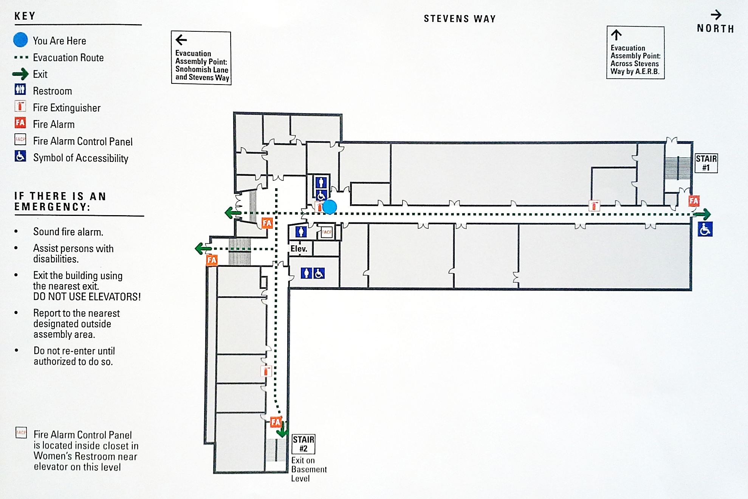
Mechanical Engineering Building – 1st Floor

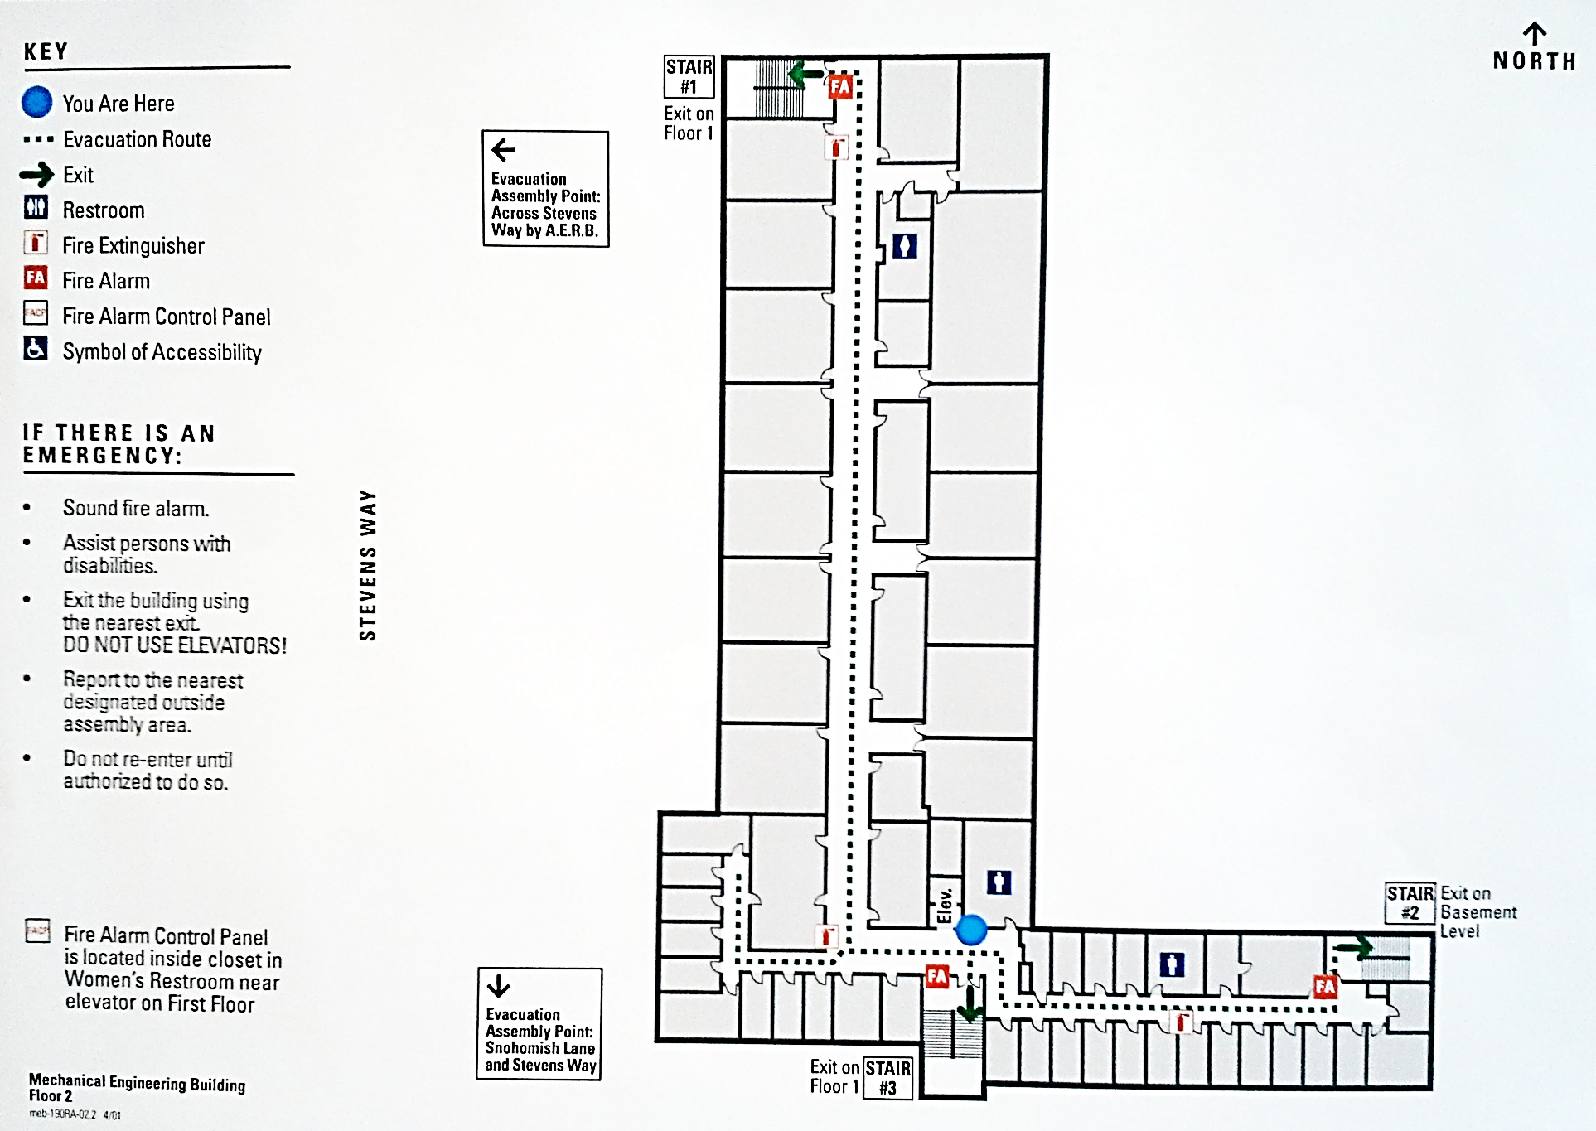
Mechanical Engineering Building – 2nd Floor

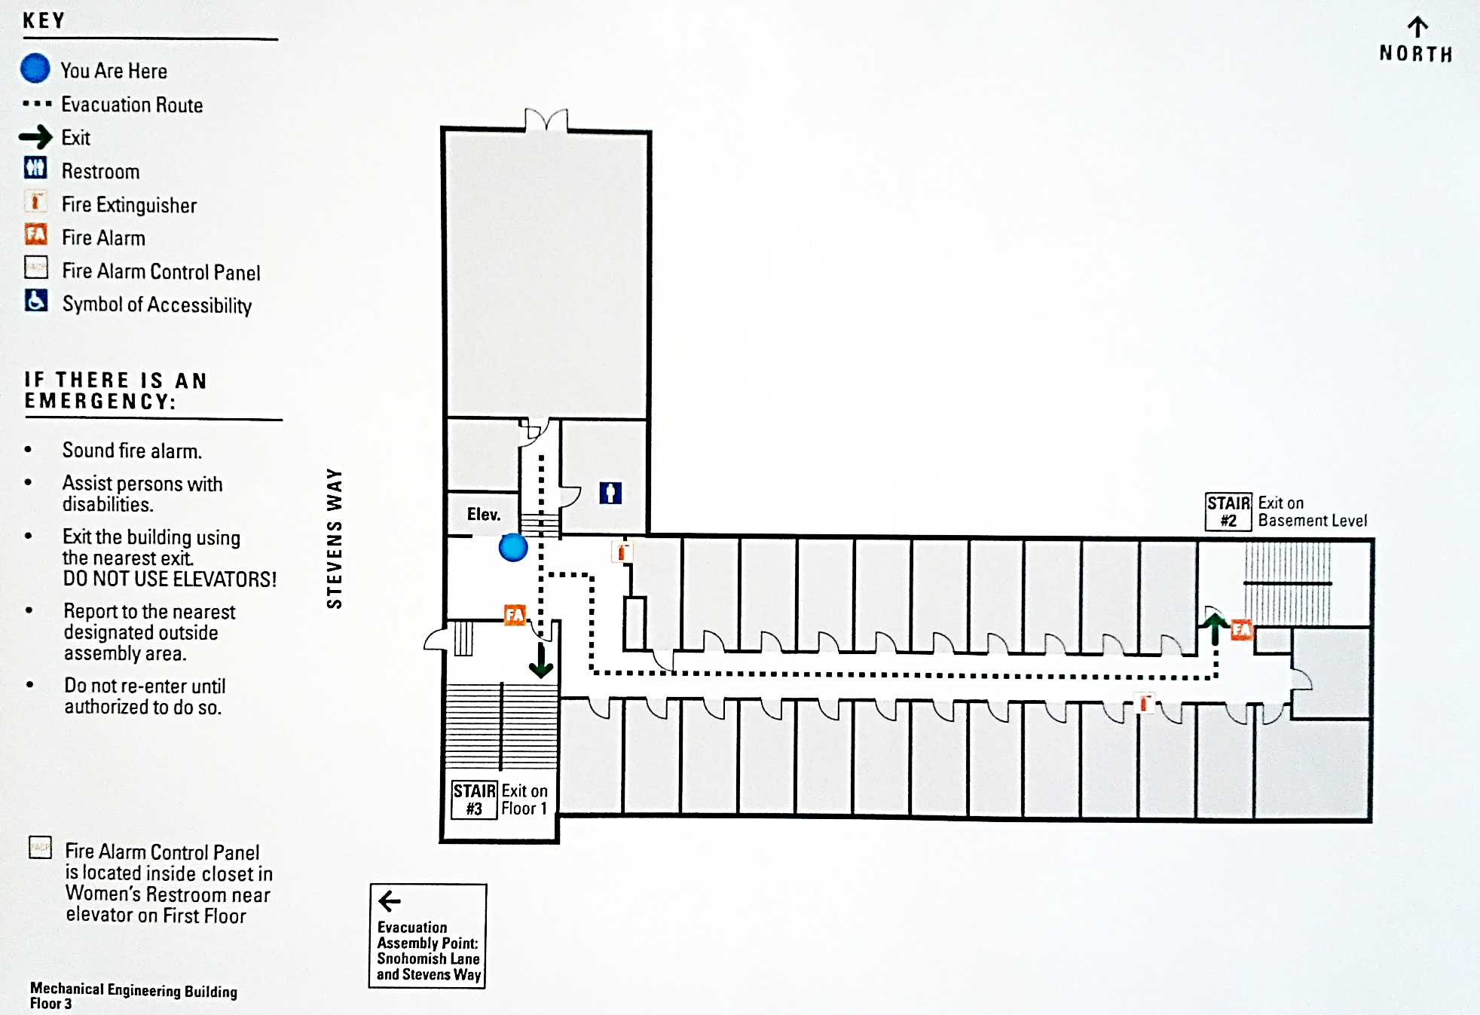
Mechanical Engineering Building – 3rd Floor

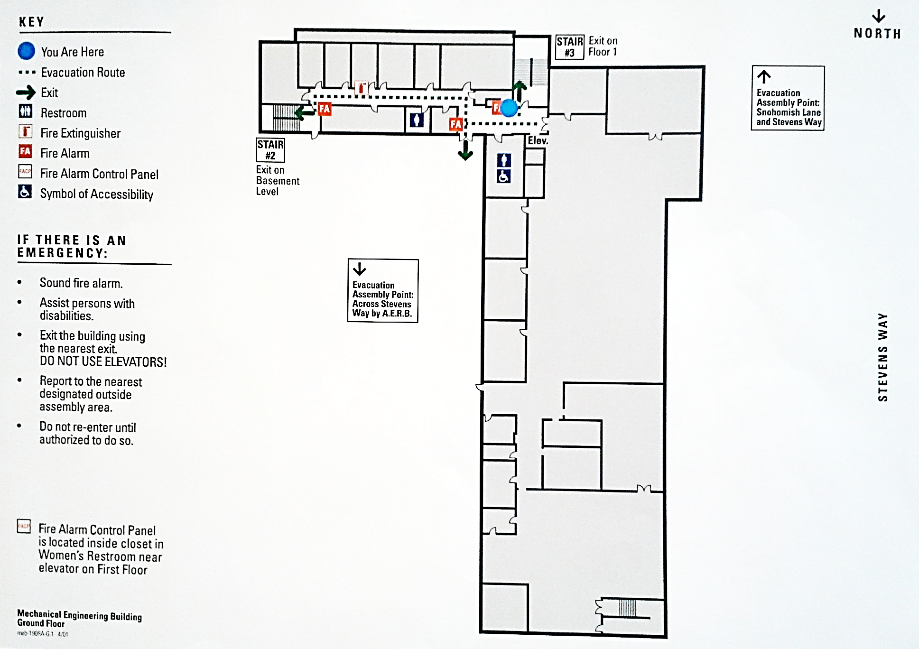
Mechanical Engineering Building – Ground Floor

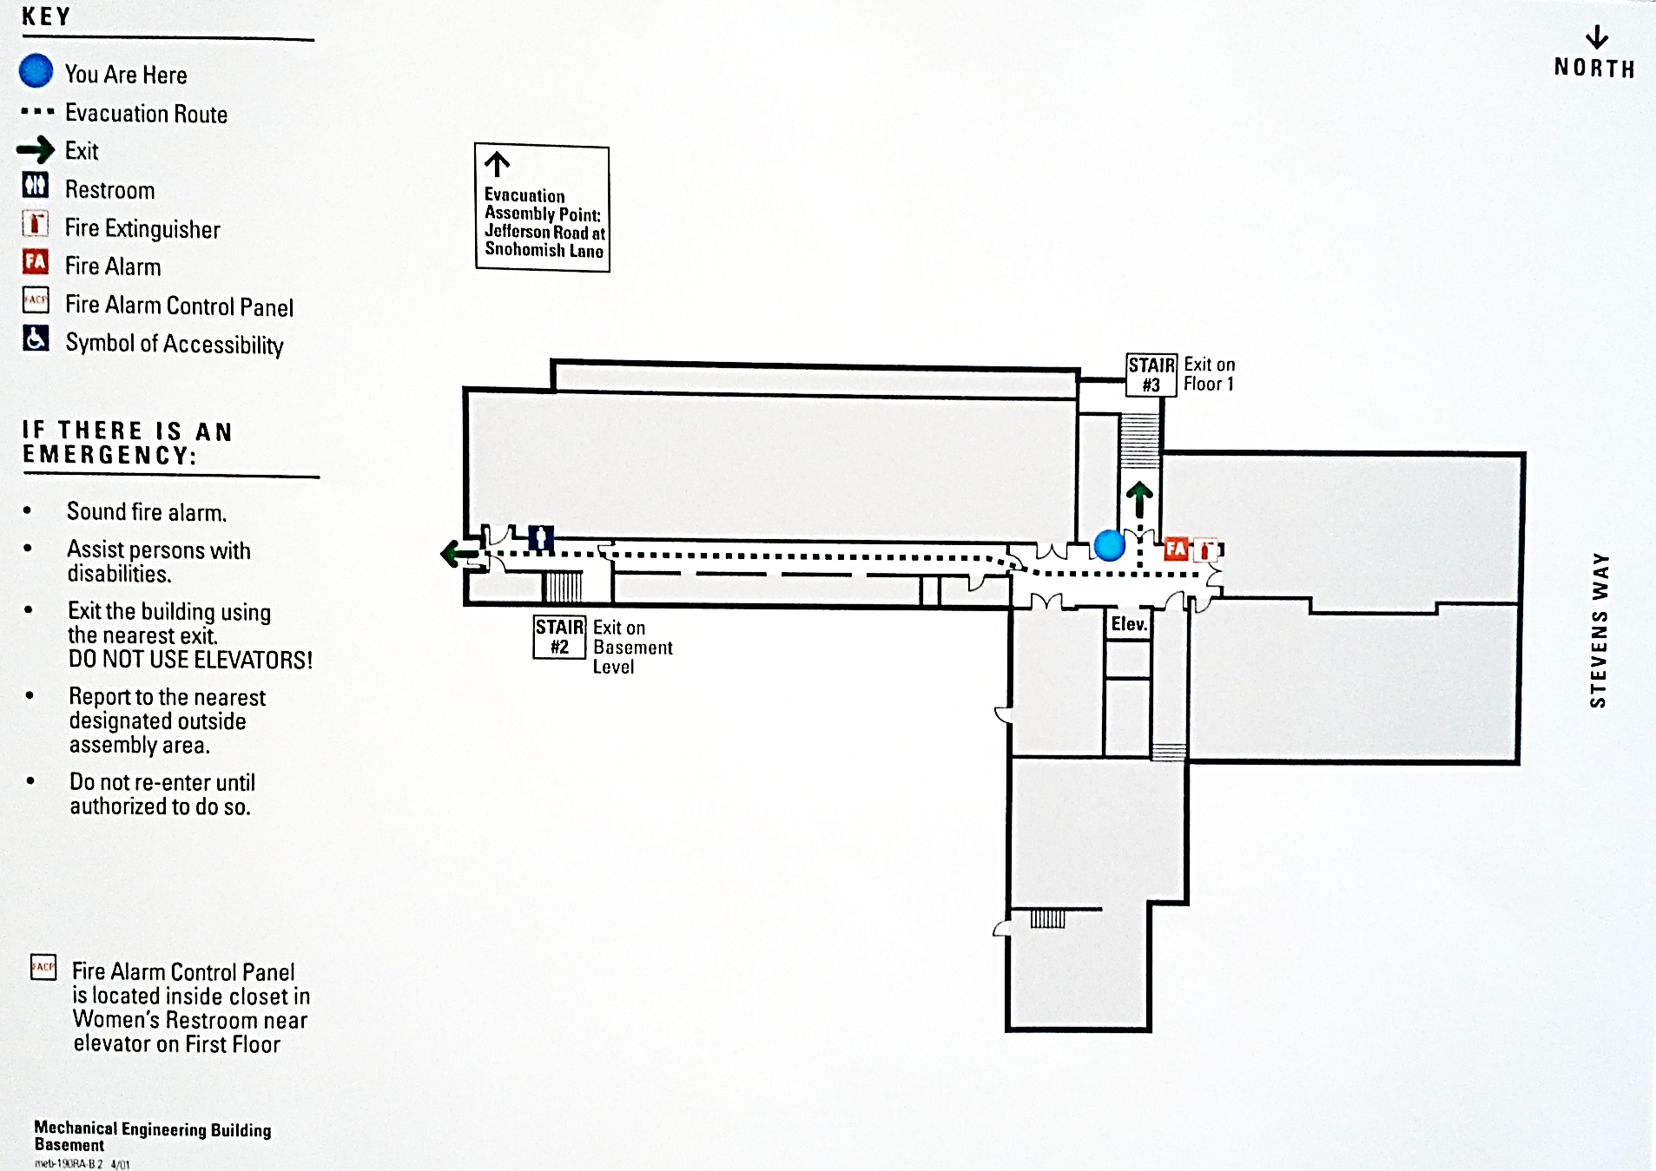
Mechanical Engineering Building – Basement Floor

Appendix D
Emergency Evacuation for Persons with Disabilities
Background
This appendix provides a general guideline of evacuation procedures for persons whose disabilities could make exiting difficult during building evacuations. Faculty, staff, students and visitors with disabilities must develop their own facilities’ evacuation plans and identify their primary and secondary evacuation routes from each building they use.
Points of Emphasis
- Be familiar with evacuation options.
- Seek evacuation assistants who are willing to assist in case of an emergency.
- Ask supervisors, instructors, Disability Resources for Students, Disability Services Office, or Environmental Health & Safety about evacuation plans for buildings.
Most UW buildings have accessible exits at the ground level floor that can be used during an emergency. In buildings like the Health Sciences Center or Padelford Hall, people can move into the unaffected wings of the building rather than exiting. However, in most UW buildings people will need to use stairways to reach building exits. Elevators cannot be used because they have been shown to be unsafe to use in an emergency and in some buildings they are automatically recalled to the ground floor.
Evacuation Directors and Evacuation Wardens need to pre-identify staff, faculty, and students with disabilities and their locations. Determine their evacuation options, identify Areas of Refuge, coordinate obtaining an Assisted Evacuation Device (as needed – see below), and determine how they will evacuate from the building.
Individuals are also encouraged to sign up for UW Alerts on the UWEM website. UW Alerts will broadcast information electronically during crises or emergencies that may disrupt routine UW campus operations.

Evacuation Options for Persons with Disabilities
Persons without disabilities must evacuate to the nearest exit. Persons with disabilities have five basic evacuation options.
- Horizontal evacuation: Use building exits to the outside ground level or go into unaffected wings of multi-building complexes.
- Stairway evacuation: Use steps to reach ground level exits from the building.
- Stay in Place: Unless danger is imminent, remain in a room with an exterior window, a telephone, and a solid or fire-resistant door. With this approach, the person may keep in contact with emergency services by dialing 911 and reporting his or her location directly. Emergency services will immediately relay this location to on-site emergency personnel, who will determine the necessity for evacuation. Phone lines are expected to remain in service during most building emergencies. If the phone lines fail, the individual can signal from the window by waving a cloth or other visible object.
- Area of Refuge: With an evacuation assistant, move to an area of refuge away from obvious danger. The evacuation assistant(s) will then go to the building evacuation assembly point and notify the on-site emergency personnel of the location of the person with a disability. Emergency personnel will determine if further evacuation is necessary.
- Assisted Evacuation Device: In the event of a major earthquake or other campus-wide event that would prevent first responders from responding quickly, an assisted evacuation device such as a chair, can be used by trained personnel to evacuate mobility disabled persons.

Disability Guidelines
Prior planning and practicing of emergency evacuation routes are important in assuring a safe evacuation. In addition, helpers and others who may assist those with disabilities are reminded to always ask someone with a disability how you can help before attempting any rescue technique or giving assistance. Ask how he or she can best be assisted or moved.
Mobility Impaired: Wheelchair
Persons using wheelchairs should stay in place, or move to an area of refuge with their assistant when the alarm sounds. The evacuation assistant should then proceed to the evacuation assembly point outside the building and tell SFD or UWPD the location of the person with a disability. If the person with a disability is alone, he/she should phone emergency services at 911 with their present location and the area of refuge they are headed to.
If a stair landing is chosen as the area of refuge, please note that many campus buildings have relatively small stair landings, and wheelchair users are advised to wait until the heavy traffic has passed before entering the stairway.
Stairway evacuation of wheelchair users should be conducted by trained professionals (Fire & EMS). Only in situations of extreme danger should untrained people attempt to evacuate wheelchair users. Moving a wheelchair down stairs is never safe.
Evacuation devices such as evacuation chairs may be used when first responders are unavailable. This could occur following a campus-wide emergency such as an earthquake or weapons of mass destruction (WMD) event. The following requirements must be met when using evacuation devices:
- Contact EH&S at 206-616-5519 to identify an appropriate device and determine where to store or place the device. In general, this will apply to departments with a mobility impaired employee whose primary work location is above the ground floor.
- Assign a primary and secondary user of the evacuation device.
- Each user must be a trained Evacuation Warden who has attended the Evacuation Warden training class offered by EH&S.
- Train each user on the proper operation and use of the evacuation device. Coordinate this training with EH&S Building and Fire Safety (206-616-5519).
- Update and document this training annually.
- Install the evacuation device in a location where it cannot impede egress of others from the building. The device will be used only by the assigned users and only when first responders are unavailable to assist a mobility impaired person to evacuate.
- Evacuation devices will be available for use by specially trained Evacuation Wardens only.
- Update the building’s Emergency Evacuation and Operations Plan by describing the standard operating procedures for the evacuation device.

Evacuation Plan for Persons with Disabilities
Personal Information
Name |  | Location |  |  |  | Phone
Supervisor name |  | Phone |  |  |  | Cell Phone
Emergency contact name |  | Phone |  |  |  | Alt. Phone
Type of Disability
Mobility |  |  | ☐
 |  |  |  | Blind |  |  |  |  | ☐
Deaf/hard of hearing |  |  | ☐
Service animal user |  |  | ☐ | Other: Describe Here |  |  |  |  | ☐
Limitations and information emergency personnel should be aware of (including medication)

Evacuation Plan (make one for each building that you occupy)
Building name | Time of day generally in building
Days generally in building | Sun  ☐ |  | Mon  ☐ | Tue  ☐ | Wed  ☐ |  | Thu  ☐ | Fri  ☐ |  | Sat  ☐
Date completed: (mm/dd/yyyy)

Effective dates:

Key Personnel to Contact for Assistance in Developing Your Evacuation Plan
Name | Title | Phone
Designated Buddies
Buddy #1 Name: | Address/Office: | Phone:
Buddy #2 Name: | Address/Office: | Phone:
Evacuation Plan (Describe plan for evacuation. Include location for Stay in Place or Area of Refuge):
Primary Evacuation Route (include Evacuation Assembly Point):
Secondary Evacuation Route (if primary route becomes inaccessible during emergency):
Assistance Instructions (Such as medical, equipment, communication and carry instructions):

Appendix E
Procedures for Planning and Scheduling Evacuation Drills

Preparation for an Evacuation Drill
- Meet with Evacuation Director and Evacuation Wardens
- Review procedures, duties, evacuation routes as outlined in the plan
- Determine who will participate in the drill
- Confirm participants are familiar with the plan
- Establish a date and time for drill that is convenient but assures appropriate participation
- Notification and Technical Assistance
- Call Facilities Services Signal Shop at (206) 685-1471 or (206) 685-1409 to arrange for a technician to activate the alarm system and reset it after the drill
- Notify UWPD of the time and date of the drill
- For assistance in conducting and evaluating the drill, notify EH&S Building and Fire Safety Office at least one week in advance at(206) 616-5519
- Publicize Drill Event to Building Occupants
- Approximately three days before the drill post notices in conspicuous locations informing all occupants of the time and date of the drill.
- Notification via e-mail and other means is also encouraged.

The Day Before a Drill
- Prepare any Special Props for the Drill (optional):
- Cardboard flames or balloon for location of fire
- Cardboard smoke barriers to indicate blocked corridors and/or stairways
- Confirm Responsibility Roles with Players:
- Building staff (Evacuation Director and Evacuation Wardens)
- Facilities Services Signal Shop to activate the alarm system

Appendix F
Conducting, Evaluating and Recording Evacuation Drills

Conducting an Evacuation Drill
Participation
Chapter 4 of the Seattle Fire Code along with The Washington Administrative Code (WAC) 296-24-567 requires that all employees train a sufficient number of persons to assist in safe and orderly emergency evacuation of employees. To meet this requirement and satisfy public safety for all students, faculty, staff, and visitors, University buildings must conduct a Evacuation Drill that will include the participation of all the building occupants. It is recommended that the annual drill be conducted during Autumn Quarter to orient new faculty, staff and students.
Evaluating and Recording an Evacuation Drill
- The Evacuation Director will summarize evaluation comments and initiate appropriate follow-up for items that need improvement.
- The Evacuation Director will complete and distribute the Evacuation Drill Report Form (attached).

Appendix G
Evacuation Drills and Crowd Management for Public Assemblies

Conducting the Evacuation Drill
Participation
Chapter 4, Section 405.2 of the Seattle Fire Code requires employees (event staff) of public assemblies to participate in Evacuation Drills every quarter (not to exceed 120 days). Patrons are not required to attend or participate. To meet this requirement assembly occupancies will:
- Every quarter or prior to the event, the building Evacuation Director, or appointee, will meet with event staff to conduct a drill or exercise to review employee procedures and duties.
- A drill, exercise, or orientation will be performed whenever there is a change in staff, building/exit configuration, or other substantive change.
Evaluating and Recording an Evacuation Drill
- The Evacuation Director will summarize evaluation comments and initiate appropriate follow-up for items that need improvement.
- The Evacuation Director will complete and distribute the Evacuation Drill Report Form (attached).

Crowd Management
Trained Crowd Managers shall be provided for facilities or events where more than 1,000 persons congregate. The minimum number of crowd managers shall be established at a ratio of one crowd manger to every 250 persons.

Duties of crowd managers include but are not limited to the flowing:
- Walking the rooms or areas and confirm that the exit paths are staying clear.

- Make an emergency announcement with specific evacuation instructions if need be.

- Not allowing people to congregate around or block any exits.

- Assure all marked exits remain unlocked and unobstructed at all times.

- Looking for situations that could lead to challenges in the event of an emergency evacuation.

- Maintain all fire lanes, fire hydrants, and fire department connections free from vehicles and obstructions.

- Make sure that the adequate number of trained staff on-duty for the number of occupants.

Appendix H

Evacuation Drill Report Form
To record an Evacuation Drill, please use the UW 1213 form. The next page features a copy of the form that may be printed and filled out by hand. To request a hard copy of the form from Building and Fire Safety, please call (206) 616-5519.
An electronic copy of the UW 1213 form is available at the hyperlink below. The electronic version of the form may be filled out on your computer.
Once the form has been completed, please send it to Building and Fire Safety at UW Box #354400. Building and Fire Safety strongly recommends saving an electronic copy of the completed form for your records. If the form is filled out by hand, scan the document and save it in a reliable file format.
http://www.ehs.washington.edu/forms/fso/firedrillreport.pdf

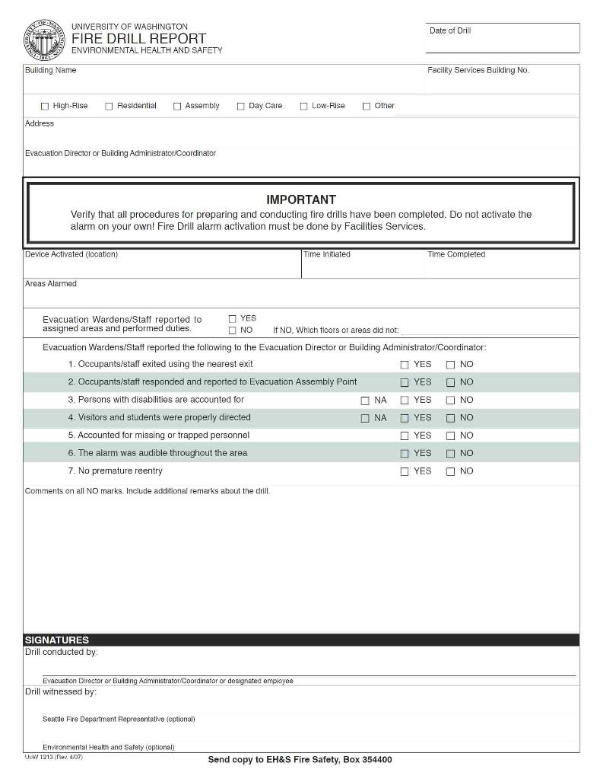

Appendix I

Evacuation Warden Headcount Checklist
Building Name: |  | Assembly Point:
Evacuation Warden: |  | Time and Date:

Employees / Visitors | Present | Absent | In Field | Injured | Missing | Last Known Location | Emergency Assignment
Name: | ☐ | ☐ | ☐ | ☐ | ☐
Name: | ☐ | ☐ | ☐ | ☐ | ☐
Name: | ☐ | ☐ | ☐ | ☐ | ☐
Name: | ☐ | ☐ | ☐ | ☐ | ☐
Name: | ☐ | ☐ | ☐ | ☐ | ☐
Name: | ☐ | ☐ | ☐ | ☐ | ☐
Name: | ☐ | ☐ | ☐ | ☐ | ☐
Name: | ☐ | ☐ | ☐ | ☐ | ☐
Name: | ☐ | ☐ | ☐ | ☐ | ☐
Name: | ☐ | ☐ | ☐ | ☐ | ☐
Name: | ☐ | ☐ | ☐ | ☐ | ☐
Name: | ☐ | ☐ | ☐ | ☐ | ☐
Name: | ☐ | ☐ | ☐ | ☐ | ☐
Name: | ☐ | ☐ | ☐ | ☐ | ☐
Name: | ☐ | ☐ | ☐ | ☐ | ☐
Name: | ☐ | ☐ | ☐ | ☐ | ☐
Name: | ☐ | ☐ | ☐ | ☐ | ☐

Evacuation Warden Headcount Checklist cont.
Page 2 of 2
Employees / Visitors | Present | Absent | In Field | Injured | Missing | Last Known Location | Emergency Assignment
Name: | ☐ | ☐ | ☐ | ☐ | ☐
Name: | ☐ | ☐ | ☐ | ☐ | ☐
Name: | ☐ | ☐ | ☐ | ☐ | ☐
Name: | ☐ | ☐ | ☐ | ☐ | ☐
Name: | ☐ | ☐ | ☐ | ☐ | ☐
Name: | ☐ | ☐ | ☐ | ☐ | ☐
Name: | ☐ | ☐ | ☐ | ☐ | ☐
Name: | ☐ | ☐ | ☐ | ☐ | ☐
Name: | ☐ | ☐ | ☐ | ☐ | ☐
Name: | ☐ | ☐ | ☐ | ☐ | ☐
Name: | ☐ | ☐ | ☐ | ☐ | ☐
Name: | ☐ | ☐ | ☐ | ☐ | ☐
Name: | ☐ | ☐ | ☐ | ☐ | ☐
Name: | ☐ | ☐ | ☐ | ☐ | ☐
Name: | ☐ | ☐ | ☐ | ☐ | ☐
Name: | ☐ | ☐ | ☐ | ☐ | ☐
Name: | ☐ | ☐ | ☐ | ☐ | ☐
Name: | ☐ | ☐ | ☐ | ☐ | ☐
Name: | ☐ | ☐ | ☐ | ☐ | ☐
Name: | ☐ | ☐ | ☐ | ☐ | ☐

Appendix J
About the UW All-Hazards Emergency Management Plan (EMP)
Background
In June of 2005, the University of Washington published a revised comprehensive Emergency Management Plan (EMP) for campus operation during large scale or campus-wide emergencies. Copies of the EMP are available at the Emergency Management website below:
http://www.washington.edu/emergency/ep
The following is a summary of the EMP.

The UW All-Hazards Emergency Management Plan
The EMP provides guidelines for the management of the immediate actions and operations required to respond to an emergency or disaster. The overall priorities of the University during a disaster are the protection of lives, live assets, valuable research processes, property, the community, and the environment. The overall objective is to respond to emergency conditions and manage the process of restoring University academic and research programs and services. This plan represents the Campus Emergency Management Plan, which encompasses the facilities, services and the administration of the UW Seattle campus.

Purpose of the Emergency Management Plan
This plan provides the management structure, key responsibilities, emergency assignments, and general procedures to follow during and immediately after an emergency. The University has established this plan to address the immediate requirements for a major disaster or emergency in which normal operations are interrupted and special measures must be taken to:
- Save and protect the lives of students, patients, employees, and the public.
- Manage immediate communications and information regarding emergency response operations and campus safety.
- Provide essential services and operations.
- Provide and analyze information to support decision-making and action plans.
- Manage University resources effectively in the emergency response.
- Ensure University-wide compliance with federal National Incident Management principles and requirements.
This plan does not supersede or replace the procedures for safety, hazardous materials response, or other procedures that are already in place at the University. It supplements those procedures with a temporary crisis management structure, which provides for the immediate focus of management on response operations and the early transition to recovery operations.
It is important to point out that this EMP does not cover specific departmental operations, even for those departments assigned emergency response functions. All departments must establish their own emergency operations plan that considers their specific needs and how they will interface with the UW EMP.

Appendix K
Emergency Procedures for Faculty, Lecturers, and Teaching Assistants

Supervisory Responsibilities
“Because of the personal nature of safety performance, everyone with supervisory responsibility will be expected to directly participate in the supervision of programs to assure that safe working conditions are maintained. Faculty and staff shall be directly responsible for their own safety, for the safety of students and employees under their supervision and for the safety of their fellow employees. This responsibility can neither be transferred nor delegated. Supervisors shall provide training for accident prevention as necessary, for those working under their direction.”
Ref: University of Washington. Executive Order No. 55. UH Volume 4, Part VI, Chapter 4, Section 1, n.d. Web.
Consistent with this order, instructors must:
- Provide his or her class or audience with general information relating to emergency procedures. This information should be shared during the first week of class or at the start of a seminar. Please note the posted information for, “Classroom Emergency Procedures and Checklist” at the end of this appendix.
- Know how to report an emergency from the classroom being used.
- Assure that persons with disabilities have the information they need. The instructor should be familiar with the student’s plan and be able to direct visitors with disabilities.
- Take responsible charge of the classroom and follow emergency procedures for all building alarms and emergencies.
Supplemental Information
Every University department and unit should have a written Emergency Evacuation and Operations Plan covering specific procedures for their facility and employees. These plans will cover events such as: fire, earthquake, power outage, bomb threat, hazardous material spills, severe weather, etc. Instructors will find it helpful to review the plans for the buildings in which they teach to see if the plans differ from the general information provided here.
The “Instructor” is an authoritative figure for the student, either consciously or subconsciously, and can influence how the student responds in an emergency. Calm, collected, and clear directions by the instructor will have a calming effect on the students. In order for the instructor to exhibit this controlled personae he or she must be prepared for emergencies.

How to Report an Emergency
Use the nearest fire alarm pull station. If possible, call 9-1-1 from any telephone. All active fire and explosion emergencies must be reported immediately regardless of size and nature by phoning 911 and/or activating the fire alarm system.
To comply with regulation and UW Policy, all incidents, including minor fires that self-extinguish and those that do not require emergency assistance or evacuation, must be reported to EH&S within 24 hours. EH&S investigates all fires to determine their cause, provide consultation, and to document the incident for reporting purposes. Please call EH&S Fire and Life Safety at (206) 543-0465, or email uwfire@uw.edu to report a fire or explosion to EH&S.
Emergency Type | Response
Fire | Activate nearest fire alarm pull station,  Call 9-1-1
Police | Call 9-1-1
Hazardous Material Spill | Call 9-1-1

Emergency Information for Faculty, Lecturers and TAs
Refer to the Classroom Emergency Procedures at the end of this appendix for additional information.
Evacuation Routes
Floor plans that show evacuation routes are posted on building walls throughout the campus. If you have trouble finding a posted floor plan, call Building and Fire Safety at (206) 616-5519.
Evacuation routes in most University buildings lead the occupants out of the building. However, in some high-rise buildings (see Appendix P) the evacuation routes may lead occupants horizontally into another wing or down a couple of floors below the source of the alarm. These high-rise buildings may have Evacuation Assembly Points for both inside and outside the building.
Evacuation Assembly Points (EAPs)
Look on the building Emergency Evacuation floor plans for the designated Evacuation Assembly Points.
Each building has designated EAPs. After the class leaves the alarmed building or area, it is important for them to go to the EAP where the presence of persons can be documented. At the EAP, the class will not interfere with responding emergency services nor place themselves at risk of injury from the emergency.
Accounting for all students can be very difficult, particularly with a large class. However, an attempt must be made. After all the students have left the room/lab, instructors can:
- Use the class roster
- Use a head count
- Ask students about the students seated next to them in the classroom to see if they are at the assembly point.
You must also account for persons with disabilities (See Appendix D).

Evacuation for Persons with Disabilities
If there is a person with a disability in the class, the instructor must be knowledgeable of their response and who may be assisting them. Four options are available to persons with disabilities:
- Horizontal Evacuation to outside or another building, if available
- Stairway Evacuation
- Stay in Place unless danger is imminent
- Area of Refuge if available
Reporting to the Evacuation Director
Notify the building Evacuation Director about any missing students and their last known location in the building. After exiting and accounting for students, the building Evacuation Director will notify emergency personnel of persons missing or trapped or persons with disabilities that are waiting assistance in areas of refuge.
Fire Alarms
Fire alarms will sound a slow WHOOP and include strobe lights for people with hearing disabilities. When the alarm sounds, everyone must exit the alarmed area according to the evacuation plan.
- Procedures that may be hazardous if left unattended should be shut down prior to evacuation.
- Verify that everyone leaves and that all the doors are closed. Closed doors significantly reduce fire and smoke damage.
Earthquakes
Most of the injuries that occur during earthquakes are caused by interior items falling on the building occupants, such as books, shelves, light fixtures, ceiling tiles and office equipment.
The first thing to do during an earthquake is to have everyone drop to the floor, cover their head, and hold that position.
After the shaking stops and if there is building damage, tell the class to collect their possessions calmly and evacuate the building to the Evacuation Assembly Point. Caution them to watch for brick and other exterior building materials that may have been knocked loose by the earthquake.
Power Outages
The University campus power system is served by the Campus Power Plant with back up from City Light and, over time, has proven to be fairly reliable, even during major windstorms. Many campus buildings are provided with emergency or standby power from the campus power plant’s emergency generators. This system is automatic and should be operational within 60 seconds.
If the power does go out during class, have the people stay in their seats for a little while and wait for the power to return. If the power does not return in a reasonable length of time (~ 5 minutes) then evacuate the classroom or laboratory. Evacuation should take advantage of available lighting unless the building is in alarm, and then use the same evacuation procedures as during a fire.
Caution the students that there is no rush and they should take their time exiting the building. Emergency lighting may or may not be functioning in the room, hallway, or stairways.

Classroom Emergency Procedures
What Emergency Preparedness materials should I have with me at class?
- Class roster
- Important telephone numbers (in addition to emergency numbers)
Contact | Phone Number
Sue Chen, Administrator | (206) 543-6835
Classroom Services | (206) 221-5000
Student Services | (206) 543-1770
Other:
When you hear the fire alarm...
- Everyone should calmly collect their coats and books and exit the classroom, lecture hall, or laboratory. Please turn off the gas supplies in laboratories.
- Verify that everyone leaves and that all the doors are closed. Closed doors significantly reduce fire and smoke damage.
- Leave the room/lab and go the nearest building exit. Know the location of alternate exits.
- Go to the Evacuation Assembly Point (See the posted floor plan in the exit corridors). Exception: Persons with disabilities may choose to remain in place or report to an area of refuge. See the University brochure, “Campus Health and Safety, Emergency Evacuation for Persons with Disabilities”.
- Account for students by using class roster. Notify the building Evacuation Director about any missing students and their last known location in the building.
When there is a power outage...
- Everyone should stay in their seat to see if the outage is temporary and to let their eyes adjust to the lower light level.
- If the outage appears to be long term, everyone should calmly collect their materials and carefully exit the building.
If there is an earthquake…
- Everyone DROPS to the floor, COVERS their head, and HOLDS that position.
- After the shaking stops, calmly evacuate the building to Evacuation Assembly Point. Evacuation floor plans are posted on walls for reference.
Note: Additional information on emergency procedures, evacuation routes, and floor plans can be found posted on the walls.

Appendix L
Emergency Evacuation and Planning Checklist
Instructions
This emergency evacuation and planning checklist is provided by EH&S for Evacuation Directors and Evacuation Wardens to assess the readiness of their buildings for emergency evacuations. This checklist focuses on practices and procedures as outlined in the model EEOP. It is recommended that Evacuation Directors complete this checklist annually.
This checklist is composed of two parts. Part 1 contains a list of questions only. Part 2 contains the same list of questions, but also includes references and links to resources to assist Evacuation Directors and Wardens identify the necessary corrective actions to comply with EEOP procedures.
The procedures for completing this form are as follows:
- The Evacuation Director should complete this checklist with assistance from Evacuation Wardens as needed.
- Maintain a copy of the completed checklist with the building EEOP.
- Share the completed form with the Evacuation Wardens and other stakeholders in the building for emergency evacuations.
- Correct each identified deficiency as soon as possible and document corrections on the original form.
If you need assistance correcting conditions identified in the checklist, or have any questions or concerns about fire and life safety, whether they pertain to this inspection or not, contact the Building and Fire Safety Office of Environment Health & Safety at (206) 616-5519.
This form was designed to help ensure compliance with Seattle Fire Department, International Fire Code, WISHA, and other codes and regulations.
Note: This form is not a substitute for a comprehensive survey or audit of regulatory requirements and code compliance. To obtain a self-audit checklist, visit the Environmental Health and Safety website at the address below:
http://www.ehs.washington.edu/fsosurveys/checklists.shtm

Emergency Evacuation and Planning Checklist: Part 1
Building: | Mechanical Engineering |  | Evacuation Director: | Sue Chen
Date: | 8/21/2015 |  | Evacuation Warden: | Bill Kuykendall
Please answer each of the following questions by selecting the appropriate checkbox. If the answer to any of the following questions is “No,” please see the corresponding question in Part 2 for corrective actions and websites with additional information.
1 | Do you have an up-to-date written Departmental Health and Safety Plan?  Do your employees know about this plan, where to find it, and how to use it? | Yes ☒, No ☐, N/A ☐
2 | Do you have an up-to-date written Emergency Evacuation and Operations Plan (EEOP)? | Yes ☒, No ☐, N/A ☐
3 | Have the Evacuation Director and Evacuation Wardens attended UW emergency evacuation training? | Yes ☒, No ☐, N/A ☐
4 | Are emergency evacuation drills done on a regular basis to keep employees, faculty, and staff aware of EEOP and emergency procedures? | Yes ☒, No ☐, N/A ☐
5 | Are new, temporary, and student employees informed about emergency procedures in the EEOP during the new employee safety orientation? | Yes ☒, No ☐, N/A ☐
6 | Are Evacuation Wardens familiar with the EEOP and building specific information such as escape routes, assembly points, areas of safe refuge for persons with disabilities, and how the alarm system responds? | Yes ☒, No ☐, N/A ☐
7 | Are Evacuation Wardens familiar with procedures in various types of emergencies: earthquake, fire, chemical release, bomb threat? | Yes ☒, No ☐, N/A ☐
8 | Do Evacuation Wardens and people in their areas of responsibility know the location of primary and secondary Evacuation Assembly Point(s)? | Yes ☒, No ☐, N/A ☐
9 | Do Evacuation Wardens know the locations and types of fire extinguishers in the building? | Yes ☒, No ☐, N/A ☐
10 | Are there adequate disaster supply kits and first aid kits in the building?  Are Evacuation Wardens familiar with their location? | Yes ☒, No ☐, N/A ☐
11 | Are chemical spill kits available for each lab, shop or clinical area that contains chemicals or chemical products? | Yes ☒, No ☐, N/A ☐
12 | Do Evacuation Wardens follow an established procedure to conduct a head count of evacuated building personnel at the EAP? | Yes ☐, No ☒, N/A ☐
13 | Do Evacuation Wardens know the procedures to account for persons with disabilities, visitors, and people unfamiliar with the building? | Yes ☐, No ☒, N/A ☐
14 | Do Evacuation Wardens know the location of employees in the building who have basic emergency skills (first aid, CPR, CERT)? | Yes ☒, No ☐, N/A ☐
15 | Do Evacuation Wardens know the proper procedures for re-entering a building after different types of evacuations? | Yes ☒, No ☐, N/A ☐

Other Fire / Life Safety Hazards
List any other hazardous conditions in need of correction that are not covered on this emergency evacuation checklist. Assign and document the correction of each hazardous condition or concern.
1
2
3
4
5

Other Comments
The space provided below can be used to comment on any conditions described in the above questions.
Date:

Emergency Evacuation and Planning Checklist: Part 2
Written Policies and Procedures
- Do you have an up-to-date written Departmental Health and Safety Plan? Do your employees know about this plan, where to find it, and how to use it?
Corrective Action: Develop a written Departmental Health and Safety Plan using the Sample Health and Safety Plan available from the EH&S website.
Online: http://www.ehs.washington.edu/ohshsplans/index.shtm
Completion Date:
- Do you have an up-to-date written Emergency Evacuation and Operations Plan (EEOP)?
Corrective Action: Develop a written EEOP for your building using the sample model plan for low-rise buildings at the EH&S website.
Online: http://www.ehs.washington.edu/fsoemerprep/evacplan.shtm
Completion Date:
Employee and Visitor Training
- Have the Evacuation Director and Evacuation Wardens attended UW emergency evacuation training?
Corrective Action: Register Evacuation Directors and Evacuation Wardens to attend the Floor Warden/Building Evacuation Training course offered by EH&S. Additional training, such as first aid/CPR certification and earthquake/disaster preparedness should occur as needed.
Online: http://www.ehs.washington.edu/psotrain/corsdesc.shtm
Completion Date:
- Are fire and emergency evacuation drills done on a regular basis to keep employee, faculty, and staff aware of EEOP and emergency procedures?
Corrective Action: Conduct annual fire and evacuation drills in general office and classroom buildings, and quarterly in healthcare facilities following the Evacuation Drill requirements at EH&S website. Use the Evacuation Drill Report form at the EH&S website to document the effectiveness of the drill.
Online: http://www.ehs.washington.edu/fsoemerprep/fireexitrequirements.shtm
http://www.ehs.washington.edu/forms/fso/firedrillreport.pdf
Completion Date:
- Are new, temporary, and student employees informed about emergency procedures in the EEOP during the new employee safety orientation?
Corrective Action: During new employee safety orientation, inform employees, including temporary staff and student employees, about the emergency evacuation procedures contained in the EEOP.
Online: http://www.ehs.washington.edu/forms/pso/NewEmployeeSafetyOrientation.pdf
Completion Date:

Evacuation Warden Responsibilities
- Are Evacuation Wardens familiar with the EEOP and building specific information such as escape routes, assembly points, areas of safe refuge for persons with disabilities, and how the alarm system responds?
Corrective Action: Evacuation Wardens should review the building EEOP at least annually. Be familiar with the function and activities of building staff during many types of emergencies, escape routes, areas of safe refuge for persons with disabilities, and assembly points. Be familiar with how the fire alarm system responds when initiated.
Online: http://www.ehs.washington.edu/fsoemerprep/evacwardduties.shtm
Completion Date:
- Are Evacuation Wardens familiar with procedures in various types of emergencies: earthquake, fire, chemical release, bomb threat?
Corrective Action: Evacuation Wardens must be familiar with emergency and evacuation procedures for various types of emergencies, including basic sheltering in place, and share this information with employees in their area of responsibility. Review relevant sections of EEOP and conduct periodic drills with each type of major emergency.
Online: http://www.ehs.washington.edu/fsoemerprep/emergproc.shtm
Completion Date:
- Do Evacuation Wardens and people in their areas of responsibility know the location of primary and secondary Evacuation Assembly Point(s)?
Corrective Action: Evacuation Wardens need to know the location of primary and secondary EAP(s) and share this information with employees in their area of responsibility.
Online: http://www.ehs.washington.edu/fsoemerprep/evacinfo.shtm
Completion Date:

Fire Extinguishers / Disaster Supply / Emergency Kits
- Do Evacuation Wardens know the locations and types of fire extinguishers in the building?
Corrective Action: Evacuation Wardens should familiarize themselves with the location and types of fire extinguishers in the building. Locate these on evacuation floor plans in the EEOP. Take EH&S training class on fire extinguisher use as necessary.
Online: http://www.ehs.washington.edu/fsofire/fireextinguishers.shtm
Completion Date:
- Are there adequate disaster supply kits and first aid kits in the building? Are Evacuation Wardens familiar with their location?
Corrective Action: Obtain disaster supplies sufficient for building occupants to use for at least five days. Obtain first aid kits and strategically place throughout the building. If an Automated External Defibrillator (AED) is located in the building, Evacuation Wardens should know their location.
Online: http://www.ehs.washington.edu/ohshsplans/firstaidkit.shtm
Completion Date:
- Are chemical spill kits available for each lab, shop or clinical area that contains chemicals or chemical products?
Corrective Action: Obtain chemical spill kits if needed. Familiarize Evacuation Wardens with location of kits.
Online: https://www.ehs.washington.edu/epo/spills/chemspills.shtm
http://www.ehs.washington.edu/ohshsplans/firstaidkit.shtm
Completion Date:

Evacuation Procedures
- Do Evacuation Wardens follow an established procedure to conduct a head count of evacuated building personnel at the EAP?
Corrective Action: Train Evacuation Wardens to follow a set procedure for ensuring occupants have left their area and use a checklist of names at the EAP to account for the occupants in their area of responsibility. The Evacuation Director and emergency responders need to be notified immediately about any missing personnel.
Online: http://www.ehs.washington.edu/fsoemerprep/evacwardduties.shtm
Completion Date:
- Do Evacuation Wardens know the procedures to account for persons with disabilities, visitors, and people unfamiliar with the building?
Corrective Action: Establish written procedures for Evacuation Wardens to account for persons with disabilities, special needs individuals, and building visitors after evacuation. Develop evacuation options as outlined in Appendix D of the model EEOP and as described at the EH&S website indicated below.
Online: http://www.ehs.washington.edu/fsoemerprep/assemblyoccevac.shtm
http://www.ehs.washington.edu/fsoemerprep/firesafetydirectorresp.shtm
http://www.ehs.washington.edu/fsoemerprep/disabledevacguide.shtm
Completion Date:
- Do Evacuation Wardens know the location of employees in the building who have basic emergency skills (first aid, CPR, CERT)?
Corrective Action: Maintain a list of employees who have first aid/CPR training and their locations in the building. If your building has a CERT team, know who is on the team and their location in the building.
Online: http://www.ehs.washington.edu/fsoemerprep/index.shtm
https://www.washington.edu/emergency/cert-starting-team
Completion Date:
- Do Evacuation Wardens know the procedures for re-entering a building after different types of evacuations?
Corrective Action: Familiarize Evacuation Directors and Evacuation Wardens with proper re-entry procedures. An evacuated building may be re-entered only after an "ALL CLEAR" determination is made by the Seattle Fire Department or the UW Police Department.
Online: http://www.ehs.washington.edu/fsoemerprep/emergproc.shtm
Completion Date:

Appendix M
Evacuation Director Post-Earthquake Checklist

Buildings with Special Considerations
After a mild earthquake (gentle rolling motion), the Evacuation Director may use the attached checklist as a guide to determine if a building should be (1) evacuated, and (2), if evacuated, if the building can be re-occupied without receiving an all-clear signal from the Seattle Fire Department and/or the campus ATC-20 teams.
At all times, the safety of building occupants is paramount. This checklist is primarily used for general guidance in decision-making. However, if Evacuation Directors observe ANY conditions in their building that they suspect are unsafe or that they are uncertain about, then the building should not be reoccupied until the SFD and/or ATC-20 teams have given permission to re-enter the building. Always err on the side of safety. Be aware that strong aftershocks can occur as well, which should be considered before re-occupying a building.
Note: The buildings listed below in Sections 1 and 2 require special consideration and it may be appropriate to evacuate and await re-entry until the buildings are evaluated by Environmental Health & Safety, a qualified asbestos consultant, or ATC-20 earthquake inspection teams.
- The following buildings have a moderate amount of asbestos-containing materials (i.e., fireproofing above ceilings or plaster materials on walls/ceilings) that, depending upon the severity of the earthquake, could become loose and present an exposure to occupants. A building specific re-entry plan developed by a qualified asbestos consultant is advised.
Asbestos-containing Materials
Balmer Hall | Magnuson HSB – BB Tower | Pack Forest
Communications Building | Magnuson HSB – T-Wing | Schmitz Hall
Friday Harbor Shaw Beach House | McCarty Hall | Utility Tunnels
Kincaid Hall | More Hall
- In 1991, the Earthquake Readiness Advisory Committee (ERAC) evaluated buildings on campus for damage potential in a major earthquake. The following buildings should be evacuated and not re-entered until evaluated by ACT-20 earthquake inspection teams because of higher potential for damage or greater life safety risk:
Post-earthquake Structural Risk
Anderson Hall | Gowen Hall | Pavilion Pool – Men’s
Art Building | Hutchinson Hall | Plant Operations Building
Canoe House | Lewis Hall | Raitt Hall
Chemistry Library Building | Miller Hall | Smith Hall
Denny Hall | Music Building
Faculty Center (UW Club) | Observatory

Evacuation Director Post-earthquake Checklist
Complete this checklist following a mild earthquake. Evacuation Directors should use extreme caution and care when surveying their building. If the answer is YES for those items which list (Evacuate), then evacuate the building (unless conditions outside the building are too hazardous for evacuation and assembly). Notify UWPD at 9-1-1 (or by runner if the telephone system is not working) to report the building evacuation and the reason(s) for the evacuation. The building will remain evacuated until ATC-20 structural assessment teams and/or Seattle Fire Department has cleared the building for re-entry.
If the evacuation director checks YES on one of the items on the checklist that does not list an (Evacuate) notation, then the evacuation of the building is at the discretion of the Evacuation Director. Consider if the observed conditions represent a safety or health risk to workers, students, or visitors to the building. Also report any hazardous materials spills/leaks and utility line damage to 9-1-1.
Whether the building is evacuated or re-entered, deliver a copy of this completed checklist to either the Unit Response Center or the EOC. Post a completed copy near the main entrance(s) for emergency response personnel to reference.
Building Name: |  | Date:
Evacuation Director: |  | Time:
Evac. Director E-mail: |  | Phone:

Utilities
Is the power out? (Evacuate) | Yes ☐, No ☐, N/A ☐
Are there any damaged, leaking or ruptured utilities? (Evacuate) | Yes ☐, No ☐, N/A ☐
Do you smell natural gas or hear a hissing noise from a gas leak? (Evacuate) | Yes ☐, No ☐, N/A ☐
Are there any light fixtures that are hanging loose from the ceilings, fallen on the floor, or any exposed wires? (Evacuate) | Yes ☐, No ☐, N/A ☐
Is there evidence of leaking or ruptured water lines, such as water leaking from ceilings, floors, or walls? (Evacuate) | Yes ☐, No ☐, N/A ☐
Are there damaged steam pipes or radiators? Is there visible steam leaking from these sources? (Evacuate) | Yes ☐, No ☐, N/A ☐
Are there exposed, damaged, frayed, or broken electrical cords, electrical wire/cable, or cable conduit? (Evacuate) | Yes ☐, No ☐, N/A ☐
Are there damaged sinks, toilets, piping or other plumbing? (Evacuate if water is leaking or running uncontrolled) | Yes ☐, No ☐, N/A ☐
Is hot water heater(s) detached or leaking? (Evacuate if the water heater is gas-fired) | Yes ☐, No ☐, N/A ☐
Are telephones and/or computer network out of order? | Yes ☐, No ☐, N/A ☐

Mechanical / Electrical Equipment
Is there damaged air handling equipment such as fans, fan motors, or ductwork? (Evacuate) | Yes ☐, No ☐, N/A ☐
Are there damaged electrical panels, circuit breakers, or leaking transformers? | Yes ☐, No ☐, N/A ☐
Are elevator doors stuck in a closed or partially open position? (Evacuate) | Yes ☐, No ☐, N/A ☐
Is the elevator stuck between floors? (Evacuate) | Yes ☐, No ☐, N/A ☐
Have any appliances such as refrigerators and freezers toppled over? | Yes ☐, No ☐, N/A ☐
Hazardous Materials / Conditions
Are there fires in the building too large to be contained by a trained and competent person with a fire extinguisher (larger than a wastebasket)? (Evacuate) | Yes ☐, No ☐, N/A ☐
Have hazardous chemicals or other hazardous materials leaked or spilled, and is the spill larger than can be cleaned up with a chemical/biological spill kit by competent and trained personnel? (Evacuate) | Yes ☐, No ☐, N/A ☐
Are there any damaged or leaking compressed gas cylinders, high pressure vessels, or storage tanks? (Evacuate) | Yes ☐, No ☐, N/A ☐
Have numerous bookcases, filing cabinets, computer monitors, and other building furnishings toppled over? Are they blocking emergency exits? (Evacuate) | Yes ☐, No ☐, N/A ☐
Is there damaged pipe insulation or fireproofing that are labeled or known to be asbestos-containing? (Evacuate) | Yes ☐, No ☐, N/A ☐

Walls, Floors, Ceilings, and Windows
Are there uneven floors, buckled carpets, or broken tile/vinyl flooring? (Evacuate) | Yes ☐, No ☐, N/A ☐
Do any walls, support columns, or beams appear bent, twisted, sagging or leaning? (Evacuate) | Yes ☐, No ☐, N/A ☐
Are there severe cracks in the walls? (Evacuate) | Yes ☐, No ☐, N/A ☐
Are there any doors or windows difficult to open or close? (Evacuate) | Yes ☐, No ☐, N/A ☐
Is the suspended ceiling framework bent, twisted, or fallen? (Evacuate) | Yes ☐, No ☐, N/A ☐
Is there damage to stairs, stairwells, or handrails? | Yes ☐, No ☐, N/A ☐
Are there displaced or fallen ceiling tiles? | Yes ☐, No ☐, N/A ☐
Are there damaged or broken windows and/or window frames? | Yes ☐, No ☐, N/A ☐
Building Façade / Outdoors
Are any outside building components (brick, mortar, stonework, chimneys) cracked or broken? Are there chunks of debris on the ground near the base of the building? | Yes ☐, No ☐, N/A ☐
Are there downed trees, power poles, and electrical wires outside the building? | Yes ☐, No ☐, N/A ☐
Deliver a copy of this completed checklist to either the Unit Response Center or the EOC. Post a completed copy near the main entrance(s) for emergency response personnel to reference.

Appendix N

List of Acronyms
ATC-20 Applied Technology Council (Rapid Assessment Teams for Earthquakes)
CERT Campus Emergency Response Team
EAP Evacuation Assembly Point
ECS Emergency Communication System
EEOP Emergency Evacuation and Operations Plan
EH&S Environmental Health and Safety Department
EOC Emergency Operations Center
EMP All-Hazards Emergency Management Plan
FOMS Facility Operations Maintenance Specialist
HVAC Heating, Ventilation, and Air-Conditioning
ICS Incident Command System
MSDS Material Safety Data Sheet
MyChem EH&S Online Chemical Inventory Management System
OEM Office of Emergency Management
SFD Seattle Fire Department
SOP Standard Operating Procedure
UW University of Washington
UWPD University of Washington Police Department
WAC Washington Administrative Code

Appendix O

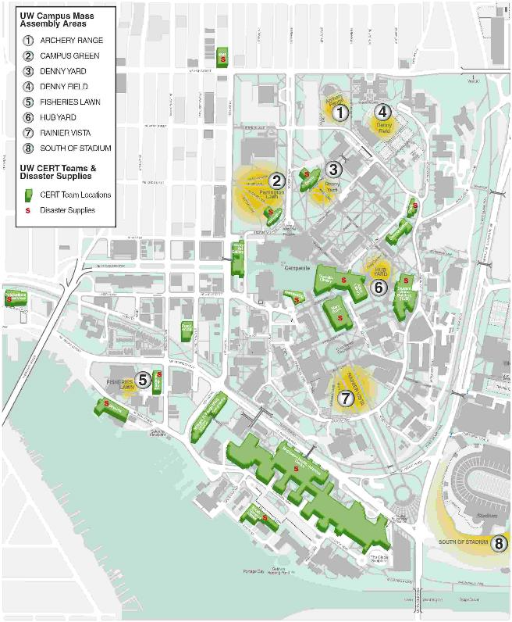
Current UW Mass Assembly Areas

Appendix P
Additional Requirements for High-Rise Buildings
There are a number of additional requirements that may apply for high-rise buildings. On the UW campus, the additional requirements of this appendix apply to the following high-rise buildings:
High-rise Buildings
Atmospheric Science and Geophysics | Health Sciences K Wing | Physics/Astronomy Building
Condon Hall | UW Tower | UW Medical Center
Haggett Hall | McMahon Hall
Health Sciences BB, RR, and AA Wings | Padelford Hall

High-rise Evacuation Plans
The Seattle Fire Department requires the development of a printed document that serves as an important resource for building staff and firefighters. Much of the information is already included in this plan. Examples of other information that needs to be addressed include:
- Evacuation specific to high-rise
- Responsibility and Control
- Specific Information about the building that is important for firefighting (fire pumps, emergency power generators, HVAC control, public address systems, etc.)
- High Value Areas
- Post Fire Operations
- Floor Plans
- Utility Information
Other useful information may be found at the following SFD web site:
http://www.seattle.gov/fire/pubEd/highrise/highrise.htm
In addition, Unit 2 (FOMS) in Facilities Services and the UWPD play key roles in supporting the fire department in some of the topics listed above.
Please confer with EH&S to assist in the development and assembly of this additional information.

Evacuation Planning and Drills
Seattle Fire Code, Chapter 4, Client Assistance Memo (CAM) 5051 Fire Safety and Evacuation Plans, 5963 High Rise Emergency Evacuation Drills, 5982 High Rise Fire Emergency Planning Requirements require that high–rise facilities have Evacuation Drills or related activity at least annually. EH&S should be consulted to help plan your drill. The Seattle Fire Department provides very helpful information which may be found at:
http://www.seattle.gov/fire/FMO/firecode/CAM/5051CAM%20Evac%20Plans.pdf
http://www.seattle.gov/fire/FMO/firecode/CAM/5963CAM%20hirise%20drills.pdf
http://www.seattle.gov/fire/FMO/firecode/CAM/5982CAM%20Hirise%20Planning%20Req.pdf
In addition to the outside assembly point, inside assembly points may be required for a high-rise building. Interior assembly is intended to provide a safe area of refuge in very tall buildings where it is impractical to travel down stairs to grade. For buildings less than about eight stories in height, it may not be necessary to identify an inside assembly point in your building. Evacuating to the exterior is always an acceptable option.
For taller high-rise buildings, the inside assembly point should, as a guideline, be the floor level that is four floors below the floor evacuated, or in an adjacent wing on the same floor that is separated by fire resistant construction and determined to be a safe area of refuge by EH&S and the Seattle Fire Department. Please work with EH&S to help identify inside assembly points.

Special Instructions for Evacuation Wardens
During evacuation, direct occupants to the stairwells and tell them where to reassemble. In high-rise buildings, this is often four floors below the fire floor (see guidelines above and Appendix C). If you have helpers, station them in front of the elevator to make sure no one attempts to use it. Do not go to the roof unless all other exits are blocked and it is the only way out. Helicopter rescue is usually impossible. If the stair is full of smoke, go to another stair.

High-rise Procedures for Occupants
Go to your predetermined assembly point as outlined in Appendix C.
In a high-rise building, you may have two predetermined assembly points, one inside and the other outside. Which assembly point you use will be based on the number of floors above grade and the number of floors in alarm. Depending on the size of the building there may even be more than one outside assembly point.

Appendix Q

UW Health and Safety Plan
For the University of Washington Health and Safety Plan please go to the following web page and download the template. The template will need to be populated with information specific to your particular building or department and maintained alongside your EEOP.
http://www.ehs.washington.edu/ohshsplans/index.shtm

Date updated: | 08/21/2015

